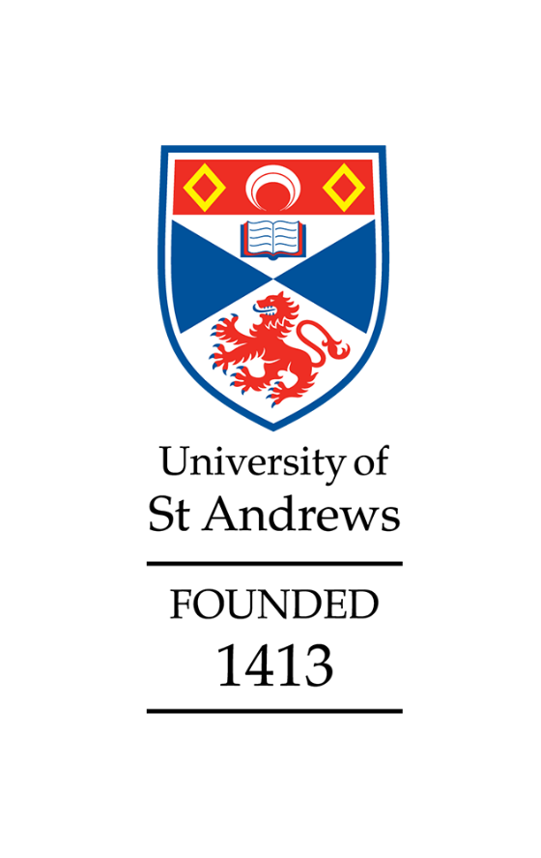

School of Art History
Athena Swan
Silver application
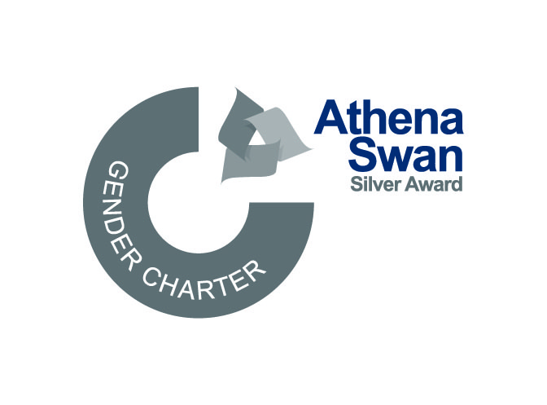
Awarded with Conditions (criteria C)
May 2025
Applicant information
Name of institution | University of St Andrews
Name of department | School of Art History
Date of current application | January 2025
Level of previous award | Bronze
Date of previous award | April 2019
Contact email | arthistedi@st-andrews.ac.uk

Table of Contents
Section 1: An overview of the department and its approach to gender equality 2
1. Letter of endorsement from the head of the department 2
2. Description of the department 4
3. Governance and recognition of equality, diversity and inclusion work 7
4. Development, evaluation and effectiveness of policies 9
5. Athena Swan self-assessment process 9
Section 2: An evaluation of the department’s progress and success 12
1. Evaluating progress against the previous action plan 12
2. Evaluating success against department’s key priorities 13
Section 3: An assessment of the department’s gender equality context 17
1. Culture, inclusion and belonging 17
2. Key priorities for future action 23
Section 4: Future Action Plan 28
1. Action plan 28
Appendix 3: Glossary 66

Section 1: An overview of the department and its approach to gender equality

1. Letter of endorsement from the head of the department

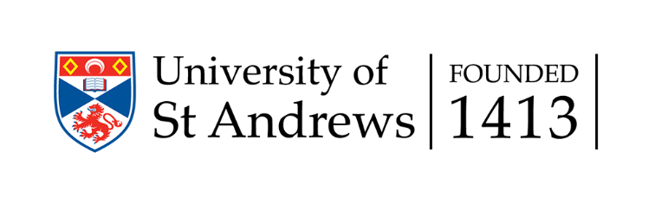
22nd January 2025
Dear Athena Swan Coordinator,
I became Head of the School of Art History in August 2022, the second consecutive woman to hold this role. One of the first tasks I undertook was to meet with our Director of EDI to discuss our options for an Athena Swan application. After consultation with the School’s Management Committee and University Vice-Principal (People and Diversity) we took the decision of working on a Silver Award application.
Since our first Athena Swan award (Bronze, in 2019), the School has made a tremendous effort to implement the action plan and to improve on all aspects of gender equality and EDI more broadly, and we enthusiastically embarked on this initiative, with the full support of the entire School. Several colleagues have been involved in this application, and they all have been incredibly helpful and collaborative. Writing this document has been a very positive exercise for all of us, and the vast majority of colleagues in our School are now better informed and even more committed to promote the values of equality, diversity, and inclusion.
Having been at St Andrews for over 10 years, I have seen positive changes in how the careers of women are supported and how the School views and values EDI work, and this has only increased since obtaining our Bronze Award. In planning all our activities, gender balance and diversity are always considered. Our staff gender balance has improved, and we increased representation of women in senior roles. We provide robust support for promotion processes, and we conduct annual reviews aimed at supporting career development;
In the last four years,
- we have supported the promotion of 11 female members of staff, four of them to Professor;
- we have restructured the EDI committee to improve diversity and representation and established a staff and student Wellbeing Officer role;
- we have been proactive in mitigating casual contracts, moving fixed-term staff (predominantly women) to permanent contracts;
- we have introduced new budget structures to provide EDI training for staff and students;
- our workload model has been further developed and enhanced, and we have increased workload recognition for major administrative roles and strengthened support structures for colleagues taking on these roles.
- We are keen to involve a wide range of voices in administrative and decision-making processes, including student-led activities, and are proud of our vibrant School community. Our achievements in gender equality empower us to embrace an intersectional strategy that recognises how gender equality intersects with equality related to race, sexuality, disability and socio-economic background.
While we are proud of the progress we have made, we recognise that we can still improve and have developed our new action plan to build on our achievements, including:
- further expanding the work to diversify our curriculum;
- supporting career progression through targeted actions for early- and mid- career staff and with a focus on women;
- recognising intersectional inequalities and ensuring our practices are inclusive of those with disabilities and other protected characteristics;
- building culture, community and trust and facilitating an inclusive environment for all.
Identifying the positive effects of implemented changes and areas needing enhancement, we remain dedicated to implementing our future action plan, tracking its advancements, and persisting in instigating strategies to foster an inclusive and supportive environment.
I fully support this application and look forward to continuing our gender equality work and improving the School culture and working environment for all.

Yours sincerely,
Laura Moretti
School of Art History,
79 North Street, St Andrews, KY16 9AL.
(+44) 01334 46 2404
arthistoryhos@st-andrews.ac.uk
The University of St Andrews is a charity registered in Scotland, No: SC013532

2. Description of the department
With a global outlook and a dynamic community, the School of Art History (SAH) has been rated as the top UK Art History Department in the Guardian University Guide, and The Times and Sunday Times Good University Guide (consecutively in 2023 and 2024). The School prides itself on its diverse, friendly and welcoming atmosphere, as affirmed in its Strategic Plan (2021-6). One of 18 Schools within the University of St Andrews, the SAH is located in the centre of St Andrews, in a terrace of town houses dating from 1824-25 (Fig. 1.1).
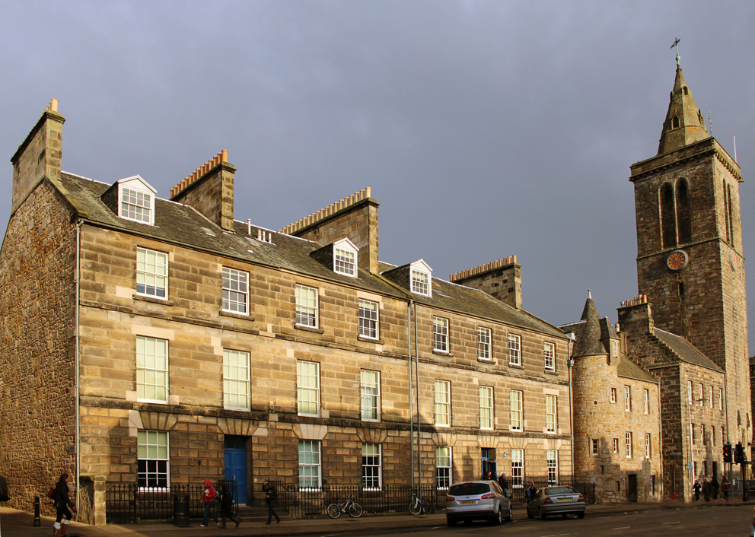
  - Figure 1.1: The School of Art History, 79 North Street, St Andrews
Founded in 1969, the School of Art History now comprises 38 members of academic and professional services staff (Fig. 1.2, Table 1.3). As our staff numbers have grown in recent years, we are proud to have significantly expanded our global range of research and teaching. Currently, the School has 256 undergraduate (UG), 47 postgraduate taught (PGT) and 28 postgraduate research (PGR) students (Table 1.1), of which 86% are registered as female by Registry. The School of Art History student body is highly international with currently 57% of students from overseas and continental Europe (comp. Table 1.4, Appendix 2). The majority (79%) of students and staff identified as white in the 2018 Survey, while 13% identified as BAME and 8% as other (comp. Table 11.1, Appendix 2). In recent years, there has been an increase in sexual diversity amongst our students: in 2023-4, 75 students (FTE) identified as LGBTQ+, 196 identified as heterosexual and 41 as unknown or prefer not to say. These figures almost double the number of LGBTQ+ students compared to 2019-20 (Table 1.2).

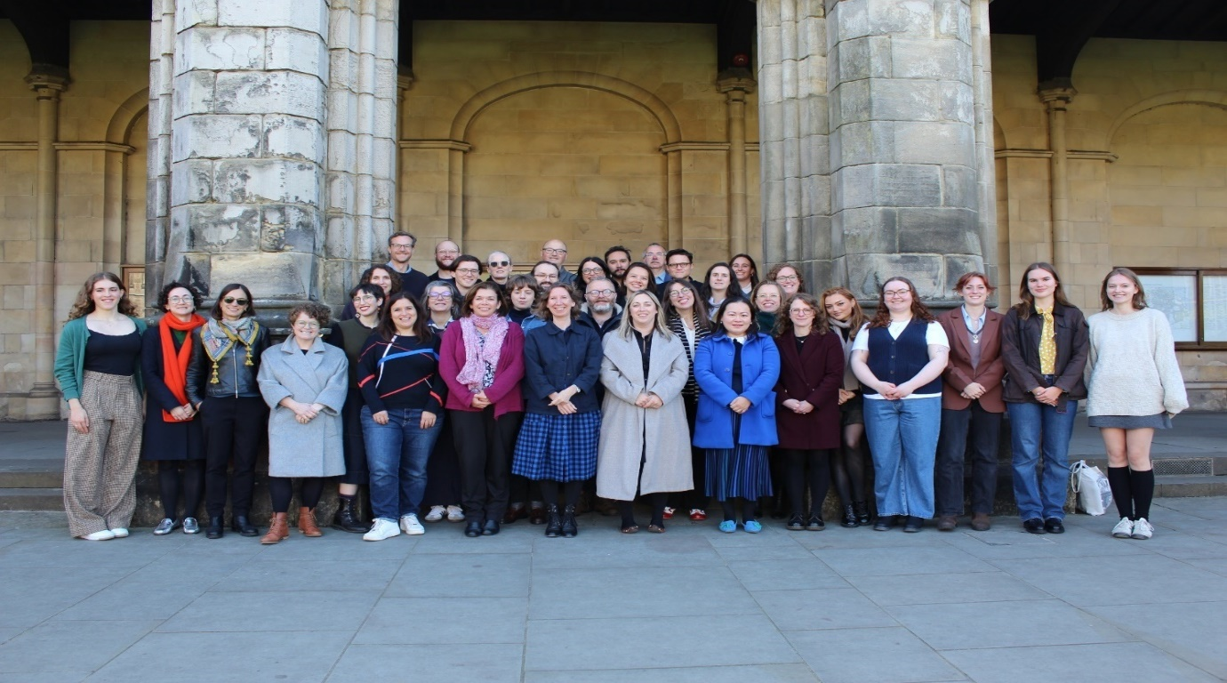
  - Figure 1.2: Many of the School of Art History’s academic and support staff and School President and students’ representatives, 2024.

Degree Level | Female | Male | Total | % Female
Undergraduate | 222 | 34 | 256 | 86%
Postgraduate Taught |  | <5 |  | 87%
Postgraduate Research |  | <5 |  | 85%
Total | 292 | 41 | 331 | 86%
  - Table 1.1: Number of students (FTE) in Art History by gender 2023-24
Student and staff numbers and gender proportions are given in Appendix 2 (we acknowledge a flaw in the data in that non-binary is not counted).
Year | LGBTQ+ | Heterosexual | Not Known / Prefer not to Say
2019-20 | 42 | 205 | 36
2020-1 | 68 | 218 | 42
2021-2 | 69 | 231 | 38
2022-3 | 69 | 190 | 33
2023-4 | 75 | 196 | 41
  - Table 1.2: Numbers of students (FTE) in the School of Art History by sexual orientation and year
St Andrews’ UG degrees are structured over 4 years total. The first two years are referred to as ‘sub-Honours’ and the last two years as ‘Honours’. The university system offers flexibility that allows for Art History students to take modules in other Schools and students from other Schools to take Art History modules. The School offers one-year PGT MLitt programmes in Art History, History of Photography (HoP) and Museum & Heritage Studies (MHS), as well as two-year research focused MPhils in Art History or Museum & Heritage Studies. We also offer a PhD programme of 3-4 years in which 28 students are currently enrolled.
Even though intersectionality and sexual diversity have increased in recent years, we recognise the lesser representation of men in the School of Art History, which according to HESA recent data reflects the demographics of our discipline more broadly: in the UK, data for 2022-3 show that the subject group History of art, architecture and design has 18% of male students. Within this context, with a majority female staff the School has played a major role in the University’s key priority (University of St Andrews AS Silver application 2024) of increasing representation of women in the Professoriate senior roles. Having promoted 11 female members of staff in the past four years – 4 of them to Professor – and with two female Head of School (HoS) since the last application, the School of Art History champions female excellence and leadership in our field.
In 2024, the School has 33 members of academic staff, 24F (73%), 9M (Table 1.3). 60% of support staff are women (appendix 2 - table 4.2.1).
Year | Female | Male | Total | %Female | %Male
2019 | 22 | 10 | 32 | 69% | 31%
2020 | 23 | 10 | 33 | 70% | 30%
2021 | 20 | 10 | 30 | 67% | 33%
2022 | 23 | 11 | 34 | 68% | 32%
2023 | 24 | 11 | 35 | 69% | 31%
2024 | 24 | 9 | 33 | 73% | 27%
  - Table 1.3: Number of academic, research, and teaching staff (Headcount) by gender and year.

Year | LGBTQ+ | Heterosexual | Not Known / Prefer not to Say
2019
2020
2021
2022
2023
Average (range) | 8% (6-11%) | 40% (36-44%) | 53% (49-56%)
  - Table 1.4: Proportion staff in the School of Art History by sexual orientation and year
The Management Committee (MC), chaired by the Head of School, includes the Director of EDI (DoEDI) as well as an Early Career (EC) member of staff (Figure 1.3). Convened twice per semester, the School Council (SC) is an all-staff meeting, which also includes the School President (SP), who is usually a fourth-year student.

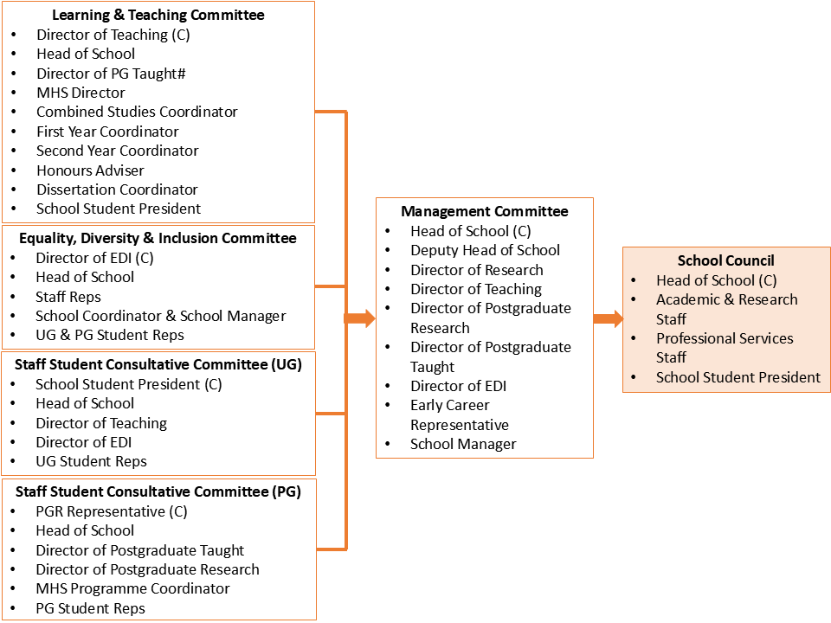

  - Figure 1.3: Management structure of the School of Art History

3. Governance and recognition of equality, diversity and inclusion work
At the School of Art History, we believe that awareness of EDI values underpins collegiality, fosters open-mindedness, and promotes well-being and work-life balance. The School’s EDI Committee (EDIC), established in 2016, currently includes the DoEDI, Head of School, 10 staff, and 5 students, including the School President. The DoEDI, as a member of the Management Committee, ensures EDI concerns are addressed at the management level and integrated into major decisions (AP3.1). At least one EDI Committee member sits on every School committee.
All job roles are represented on the EDI Committee, with membership sought through open invitations. In 2022, rotating student representatives were added to ensure diverse voices. The committee is supported by Core Working Groups in developing Athena Swan action plans.
The DoEDI leads EDI initiatives, liaising with the Head of School, coordinating operational and action plans, and providing advice to staff and students. The DoEDI attends regular meetings with other School’s DoEDI, to share good practice and receive information on EDI activity across the University. Since 2018-9, six staff members (3 female, 3 male) have held the role. The DoEDI also participates in the Committee for the Development and Diversification of the Curriculum (CDDC, since 2020) and Workload Committee (since 2021). Recognising the role's importance, workload units were increased to 15 (rising to 40 pre-Athena Swan).
The EDI Committee administers biennial surveys within School of Art History. The EDI Committee has an annual budget of £1500 for inviting seminar speakers, running training events such as the LGBTQ History Lightning Presentation, organised in collaboration with the School of History during LGBTQ History month. The EDI Committee also oversees and provides content for a dedicated EDI section of the School’s website.
Aiming to inform all members of staff, especially new hires, about policies in the School and University, the EDI Committee runs a series of information sessions regarding the promotion process, the workload model, EDI training, and HR policies.
Name | Position | Participation in WGs
 | DoEDI | CDDC, Workload, Training and events, Drafting committee
 | HoS | Workload
 | Incoming DoEDI | CDDC, drafting committee
 | School President | Training and events
 | School President | Training and events
 | School Coordinator, acting as School Manager from Oct 2024 | Workload, drafting committee
 | PG Administrator | Drafting committee
 | Director of Research | CDDC, Drafting committee
 | Director of Impact | CDDC, Drafting committee
 |  | Training and events
 | SAT member | CDDC, Data management
 |  | Data management
 | Ethics convenor | Data management
 | Research Fellow | Training and events
 | UG Student Representative | Training and events, Data management
 | Disability and Academic Support Student Rep | Training and events
 | PGT Student Representative | CDDC
 | PGR Student Representative | Data management
  - Table 1.5: EDI Committee members, 2023-4 and 2024-5

4. Development, evaluation and effectiveness of policies
Requests for changes to School-level policy, or proposal for new policies, can be made by members of staff via the relevant role holder, and/or are identified during School operational business. Changes are typically triggered by:
- monitoring of current policies by analysing demographics, progression, attainment, extension requests, etc;
- undertaking reviews of specific arrangements, proactively or in response to feedback;
- analysing informal and formal staff/student feedback (mid-semester questionnaires, module questionnaires, EDI survey and workshops).
Proposals are considered by the relevant committees and the DoEDI provides feedback on any EDI impact. Once discussed and approved, updates are presented to Management Committee and if relevant to students the Staff Student Consultative Committee (SSCC), and School Council. Similarly, changes to University policies requiring revisions to School processes are implemented by relevant committees and communicated in School Council and via email.
To ensure and evaluate their effectiveness, students are given the opportunity to share feedback on policies and processes through the Staff Student Consultative Committee meeting chaired by the School President, which meets twice each semester and includes key role holders (Director of Teaching, Head of School and DoEDI). The School has a designated HR Business Partner who advises the Head of School and all staff on the implementation of University policy to ensure that staff are able to effectively use the policies.
Staff (e.g. DoEDI/Head of School/Deputy Head of School) and student representatives help shape University policy and can suggest changes. For example, Director of Teaching (a member of the University Learning and Teaching Committee) is involved in discussions determining education-related policies. Recently, the DoEDI has contributed to the implementation process of the University policy on Trans Staff and Students (adopted since April 2023, and reviewed in April 2024) participating in discussions with students in the School and colleagues from other units.

5. Athena Swan self-assessment process
Since it was first established, the Self-assessment Team (SAT) works as a separate entity of the EDI Committee, reporting to the DoEDI. In its current configuration, SAT contains 11 members (Table 1.6) and all contributed to the drafting of the application by participating in at least one of the subcommittees established for this purpose: the data analysis committee and the drafting committee.

A description of the SAT
The new SAT was constituted in September 2023, having members being invited by the Head of School. Three student memberships, in addition to the School President, were advertised in September 2023 and again in September 2024, with students selected based on their interest in EDI and experience in data processing. The team comprises 11 members, including male and female students, the School President, support staff, and academics, assisted by the University Equality & Diversity Awards Adviser. As of September 2024, academic members are awarded 30 workload points per semester, distributed according to hours worked. Two team members specialise in Gender Studies and EDI; two have school-aged children.
Name/position | SAT Responsibility
 | Convenes SAT since Sept 2023.
 | Overview and management of policy and action plan implementation.
 | Representing professional support staff.
 | Representing academic staff.
 | Outreach activities.
 | Early-career representative.
 | PGR Representative.
 | PGT Representative.
 | Representing UG students.
 | Student Consultant. Representing UG Honours students.
 | University Awards Advisor
  - Table 1.6: Members of SAT as of September 2023

An account of the self-assessment process
Between 2019 and 2023, the EDI Committee monitored the implementation of the Athena Swan action plan and progressed actions. Learnings from the action plan, together with analysis of 2021 University staff survey and 2022 School EDI survey, and the work of the Committee for the Development and Diversification of the Curriculum and Workload Committee informed a series of recommendations by the EDI Committee to the SAT on its formation of potential core actions for the Silver action plan. The SAT first conducted a research and consultation period, including running an EDI survey in early 2024, and engaging staff and student in focus groups (covering the topics of inclusion, curriculum diversification, disability and family leave) through the summer.
A data analysis committee was convened to examine student and staff population data, identifying any key changes in data since the last application and areas of current inequalities. The development of the application was led by a drafting committee. We received external critical feedback on the application from University EDI staff and DoEDI from another School. The final application and future action plan were approved by Management Committee.
Date | Activity
2019 | School received first AS Bronze award
2020 | EDI review of 2019 action plan
2020 | CDDC established
2021 | Workload Committee established
Mar 2022 | SAH EDI Survey to Students and Staff (56 respondents)
Summer 2023 | EDIC recommend ‘core actions’ for future Action Plan
Sept 2023 | Decision to apply for Silver award by the MC informed by EDIC
Sept 2023 | School Manager post established (made ex-officio member of EDIC)
Oct 2023 | SAT data analysis committee formed
Feb 2024 | SAT report to EDIC; core actions decided
March-April 2024 | SAH EDI Survey to Students and Staff (101 respondents)
From May to September 2024 | Focus groups with students and staff
Aug 2024 | With text and key ideas contributed by the wider EDIC, the drafting committee was established to bring ideas together in narrative form
Summer 2024 | EDIC, SAT and subcommittees reconvene
Oct 2024 | Future Action Plan sent to MC for approval
Nov 2024 | SAH staff members and external review of application draft
Jan 2025 | Submission AS Silver application for a Silver Award
  - Table 1.7: SAT and EDI activities, 2023-4

Plans for the future of the SAT
The SAT’s structure of 11 members including the Head of School, academic and professional staff and 5 student members from all levels, organised in subcommittees, worked very well together. We aim to retain the existing structure of SAT after the 2024-5 academic year and to rotate the staff and student memberships to increase experience of EDI work across the School of Art History community.
The SAT team, chaired by the DoEDI, will continue to monitor the implementation of the action plan and report about SAT’s activities at School Council meetings. We will continue to measure progress in staff and student views on gender EDI by convening focus groups and running biannual Student and Staff Surveys. We will repeat information sessions to ensure our staff remain informed and up-to-date.

Section 2: An evaluation of the department’s progress and success

1. Evaluating progress against the previous action plan
A RAG-rated table of the most recent iteration of the 2019-24 Action Plan associated with our previous Bronze award is given in Appendix 4.
Actions arising from the 2019 Athena Swan award were communicated and overseen by the DoEDI. EDI Committee continued to monitor progress from 2020, and the DoEDI worked with SAT to establish which actions should be taken forward through the committee’s Working Groups. Progress was evaluated periodically by a group within the EDI Committee (DoEDI, Head of School, School Manager, previous DoEDI) and new Working Groups were created in response to specific Action Points (AP). Our previous action plan covered 7 distinct areas, focusing on 39 objectives with 137 associated actions. The final RAG rating shows 2 (5%) red, 16 (41%) amber and 21 (54%) green objectives, combining to 7 (5%) red, 34 (25%) amber and 96 (70%) green actions.
We are proud of having a high proportion of green-rated actions. Highlights are:
- Increased awareness of EDI as an underpinning tenet of good practice in the School thanks to a more effective EDI implementation structure: the DoEDI sits on the Management Committee, EDI is integrated in the annual Operational Planning, and there is now greater representation of students in the EDI committee (AP3.1, AP3.2 and AP3.3).
- Greater overall curricular diversity in Art History sub-Honours, Honours and PGT (AP2.1, AP5.6.1A, AP5.6.1B and AP5.6.12).
- Increased male applicants to School of Art History on Honours and PGT levels and insight into the reasons for low male student numbers in Art History at national and international level (AP4.1.4, AP4.1.1 and AP5.6.14).
- Increase of LGBTQ+ visibility and inclusion (AP5.6.1A and AP5.6.1B).
- Improved gender balance of academic staff (AP5.1.1A, AP5.1.1B, AP5.1.1C and AP5.1.1D).
- Successful career progression for staff members, reduction of temporary contracts, significant increase of female staff in senior positions (AP5.3.2B, AP5.3.2C, AP5.6.6, AP5.6.9, AP5.6.13A, AP5.6.13B).
The transformations in higher education priorities due to the COVID-19 pandemic, 2020-1, presented barriers to the full completion of some of the planned actions. Moreover, our perception of the gender gap in the School became more nuanced considering intersectionality, and particularly an increase in sexual diversity. The red-rated statuses of the Action Plan arise through a variety of reasons, which we categorise as follows:
- In 2018-9 some actions were thought to be achievable but, following further investigation and analysis, were found to be unachievable or not applicable to the School’s current priorities (AP4.1.2Bi-iii, AP4.1.4, AP4.1.5, AP5.5.5D).
- Insights into the reasons for low male student numbers in Art History were collected by a Focus Group (2019-20), however the School perspective on gender and the decision to champion female careers in the sector and prioritising intersectionality changed our approach to this action (AP4.1.4).
- The effects of the pandemic prevented some items being achieved within the time-period or changed the priorities within the School, which led these items to be discontinued (AP4.1.2B, AP4.1.2C, AP7.1A).
Rationale for items ending as amber-rated can be categorised as follows:
- Some actions remain in progress (AP5.6.5, AP5.6.6B).
- Some actions were taken as planned but the expected outcomes were not achieved or were not noticeable to students or staff. In these cases, some of the actions were re-discussed by SAT and retained in the Future Action Plan (AP4.2.2, AP5.1.1A, AP5.1.1B, AP5.5.4B, AP5.6.3, AP5.6.4B, AP5.6.7A, AP5.6.8A, AP5.6.8C, AP5.6.10, AP5.6.11B, AP7.1C).
- Some actions were taken as planned but the objectives were only partially achieved and involve decisions outside the remit of our School (AP7.1B, AP7.2B and AP7.2C).
- AP5.5.5A was determined to be outside the scope and remit of the School (University policy).

2. Evaluating success against department’s key priorities
This section highlights successes in three priority areas for gender equality, inclusion, and diversity: curriculum diversification, gender equality initiatives, and staff career development.

Curriculum diversification

The Committee for the Diversification and the Development of the Curriculum (CDDC)
From 2021-2, the School has a more diverse offering of Honours modules, which introduce students to art outside the Western canon and to themes relevant to EDI such as critical race studies and queer theory. Established in 2020 to accelerate diversification and decolonisation, CDDC, comprised of 4 staff members and 2 students, incorporated feminist, post-colonial, and diverse perspectives into the curriculum. The group organised faculty- and student-facing forums asking for feedback on the curriculum. As a result, new lectures, set texts, bibliography, and tutorial questions were included in modules at all levels. Furthermore, curriculum diversification has informed our recruitment processes, with more diverse expertise that helped shape the new curriculum.
Some of the significant changes in the curriculum diversification include (AP2.1A, B and C):

Undergraduate sub-Honours and Honours modules (Art History):
- From 2020-21, titles of key sub-Honours modules revised to reflect broader perspectives: e.g. 'Art in Europe and Beyond to 1600’, ‘Art in Europe and Beyond 1600-1800’, ‘Modernity, Empire and Revolution: Art from 1789–1900’.
- New lectures introduced in sub-Honours modules between 2021 and 2023, including: ‘Why Were There So Few Female Artists During the Renaissance?’, ‘Representations of Blackness in Renaissance Painting’, ‘The Persian Painter Bihzad and His World’, ‘Colonial Architecture in Latin America’, ‘Christian Arts in Ethiopia, C17th-18^{th’} ‘Slavery and Colonialism in the British Empire’. ‘Art in the Atlantic World’; ‘Classicism, Nation-Building and Colonialism in Mexico’; ‘Iranian Art in the Age of Print and Photography’. ‘Art and the Anti-Apartheid Movement in South Africa’; ‘The British Black Arts Movement’; ‘Hybridity in Latin American Figuration’.
- From 2022, the School has expanded offerings at the Honours level to include: ‘Scotland and the Arts of Africa’; ‘Decolonial, Feminist, Queer: Histories of Art in Britain Since 1945’; ‘Aspects of Japanese Visual Culture 1820-1920’; ‘Contemporary Art in the Arab World’.

PGT (Art History and Museum and Heritage Studies):
  - Core module ‘Themes in Art History’ has been reconfigured to include approaches to gender, sexuality, and sustainability.
  - ‘Art and Technology’ module has been expanded to include Latin American and Iranian Art in 2022-23, including more female artists.
  - The Museum and Heritage Studies MLitt diversified with modules on decolonisation, LGBTQ+ heritage, and antiracist practices.
  - Museum and Heritage Studies has established a partnership with the University of the West Indies to jointly offer the online taught module ‘Caribbean Cultures and Heritage: Debating Cultural Curatorship’.

Impact: As a result, the EDI Survey 2024 evidenced that 85% of staff members and 77% of students agree or strongly agree that the course curriculum is representative of a diverse range of perspectives (AP2.1). The University's Race Equality Charter working group has highlighted SAH's curricular development work as a positive example within the University.

Gender equality initiatives and career development

Student-facing initiatives:
Male underrepresentation in Art History was investigated in different capacities, informing our perception of the gender gap in the School of Art History and within the sector nationally. Efforts were made to increase the number of males applying to our UG and PG programmes, as follows:
  - Focus groups convened by the DoEDI in 2021 interviewed male students to identify barriers for applicants. Potential obstacles included perceptions of limited career prospects and the discipline's narrow focus (AP4.1.1, AP4.1.4). In response, the EDI Committee developed career guidance resources for the School website (e.g., job examples, alumni profiles, relevant websites). To expand interdisciplinarity, collaboration opportunities with other disciplines have been actively pursued. A UG joint-Honours module with Sustainable Development, approved in Jan 2022, was offered in AY2022-23; collaborative modules are being taught with Social Anthropology, such as ‘Caribbean Cultures and Heritage’; and the Museum and Heritage Studies MLitt was moved to the Graduate School of Interdisciplinary Studies from 2022-3.
  - Following AP4.1.1A, in 2023 staff members participated in the Sutton Trust Summer School, a week-long residential in St Andrews for pre-university students from under-privileged backgrounds.
Impact: Apart from a small drop in the pandemic (2020-1), the School of Art History has maintained male applicant numbers of >45 (compared to average of 40 in the years 2013-4 to 2016-7). We acknowledge that this is still low and the School realises that changing the gender demographics of the student body is a long-term ambition. Furthermore, informed by focus-group investigation, the School decided to shift its focus to fostering diversity in various ways, expanding intersectionality, while championing female success in Art History and Museum and Heritage Studies.

Staff-facing initiatives:
In 2018, 79% of Lecturers were female, while 58% of Senior Lecturers, Readers and Professors were female. The Action Plan aimed for proportionate percentages of female members of staff on all levels, with actions targeting promotions and recruitment.

A structured promotions support process has been created and implemented:
  - This process, which was designed by the DoEDI and the Head of School in 2019-20 and 2020-1, includes an annual promotions workshop with a member of Human Resources or a representative of the Dean’s office (AP4.2.1).
  - Each promotions cycle, the Head of School also convenes a panel consisting of the Head of School, the Director of Teaching, the Director of Research and one member of the professorial staff to review and advise on promotion applications (AP5.1.3A).
  - In addition, the Head of School now meets individually with all applicants for promotion, to review panel feedback (AP5.1.3D).

The recruitment process has been assessed and revised:
  - All staff attending interviews are now required to take Unconscious Bias Training (UBT). By 2024, 85% of staff had undertaken this training. In addition, information about unconscious bias included updated University webpages circulated prior to each talk by the DoEDI (AP5.1.1B and C).
  - A successful effort has been made to increase the global range of platforms on which positions are operated. Jobs have been listed on jobs.ac.uk, the Art History mailing list, College Art Association, and H-Net (AP5.1.1A). As a result, we observed an increased in international applications, with the two selection processes for Museum and Heritage Studies (in 2023 and 2024) having received applications from all continents.
  - All recruitment now takes place online (except for professorial appointments), in line with University policy (AP5.1.1B. C. D), lowering the barriers to participation for those with family or caring responsibilities as well international applicants.
  - The School has opted to include two School reps (in addition to the Head of School) – instead of one (required by the University) – for posts of a duration over 1 year, to ensure wider inclusion in the process. Since 2021, a call for expressions of interest in sitting on recruitment panels is issued by the Head of School each year and a list is held of interested participants.

Impact: Between 2018 and 2024, the percentage of female professors rose from 3% to 83%. Since 2018, 11 women and 3 men have made successful promotions applications (including 4 women promoted to Professor).

“[The] School was extremely supportive, both line manager and colleagues who commented on my application”
(Woman staff response, 2024 EDI Survey)

Mitigating career precarity of casual contracts (primarily held by women)
Education-focused (EF) and Research-focused (RF) roles are predominantly fixed-term (90% of staff in these roles were fixed-terms in 2019). These casual contracts are mostly held by women (in 2019, 7 of 9 [78%] fixed-term, EF and RF staff were female).
Following the Action Plan and the actions focusing on support for career developments and stability (AP4.2.2, AP5.1.3, AP5.3.1 and AP5.5.3), one of the areas of success involved the mitigation of casual contracts, including both female and male staff:
- Increased support encourages promotion. Academic promotion in the University is also open to staff members on fixed-term contracts. We encourage fixed-term staff to apply for promotion by offering them Annual Review (AR) meetings, encouraging them to attend the annual promotions workshop held by the Dean, and including them in our call for the submission of draft application to the School promotions panel (AP 5.1.3).
- The School hosts at least one promotions workshop per academic year, based on a preliminary promotions workshop held by the Dean in February 2020 (AP5.3.1).
- Successful promotion applications have been made by staff on a fixed-term contract, and to enable moving between job families.
- A proactive use of mentoring fosters career progression. All new academic staff are matched with a mentor from the permanent staff for the duration of their probation. The Head of School encourages uptake of the Elizabeth Garrett Mentoring Scheme (EGMS) for academic women at Grade 8 and above, both for mentors and mentees, as well as the Aurora women’s leadership scheme. The Head of School has queried the selective eligibility of the Elizabeth Garrett Scheme (specifically designed for mid-career women) with the Principal. Staff at all levels are also encouraged to participate in the Teaching, Research and Academic Mentoring Scheme. Professional Services staff have taken part in the Professional Services mentoring scheme.
- The supportive environment for career development enables staff to take senior roles in University management (Table 12, Appendix 2); e.g. Associate Dean.
Impact: Since 2020, the School of Art History improved the contracts of 8 staff on fixed-term contracts, which were made permanent appointments. In 2023, 64% (7 of 11) education-focused and research-focused roles are fixed-term and 57% of these fixed-term staff are female.
“The School has been particularly attentive to issues related to precarity with a number of staff moving to permanent contracts. Such efforts create an environment of support and care that is appreciated.”
(Woman staff member, 2022 EDI Survey)

Section 3: An assessment of the department’s gender equality context

1. Culture, inclusion and belonging
Inclusivity and Diversity are two pillars in the School’s strategic plan (2021-6), reflecting the importance of continuously diversifying our international body of staff and students, increasing gender equality, race and sexual diversity, cross-cultural exchanges and the development of Art History based on various perspectives and epistemologies. Our Strategic priorities identified include:
- Promoting gender equality while diversifying the global coverage of our teaching and research (relating to new priorities 1 and 5 defined later in this section).
- Strengthening our commitment to equality, diversity and inclusion (relating to new priorities 2, 4 and 5).
- Promoting staff and students’ well-being (relating to new priorities 3 and 4).

School Culture
The School of Art History is based centrally at 79 North Street, St Andrews, in a four-storey, fully-refurbished Georgian townhouse containing the main office, individual academic offices, shared PGR and tutor offices, project rooms for students, a lecture room seating 25 people and four dedicated small seminar rooms (all with projection facilities), the Visual Resources Library, a communal kitchen and dining room and spacious break-out areas, where informal student and staff interactions are encouraged.
The School proactively seeks to ensure that it has universally accessible classrooms, despite the constraints of the age of the building. Reasonable adjustments are put in place in response to the disclosure of disability. We make adjustments to the timing of core meetings and research activities for colleagues with constraining circumstances, health requirements or caring commitments. The Head of School and Occupational Health provide confidential support to colleagues who disclose personal circumstances. Leaves of absence are open to all students to accommodate health or personal circumstances. Members of the School have contributed to EDI initiatives in the University, especially in disability advocacy and involvement in setting up the St Andrews University Refugee and Forced Migration Network as well as in the institutional application to the Race Equality Charter.

A welcoming environment for staff and students:
The School of Art History offers a welcoming environment in which to work and study (Student and Staff surveys 2022 and 2024). Our achievements are made possible by the vibrant, collegial and flexible atmosphere that we have worked together to create. According to respondents to the 2024 survey:
“The School of Art History is led in a way that everyone feels to be part of its achievements and equally responsible for its academic excellence. It is a welcoming environment to all, taking diversity very seriously in its recruitment processes and it it overall activities.”
(Woman staff member, EDI Survey 2024)

“Art History Garden Party, the Pub Quiz, the Jazz Night, the Mentoring Scheme Pub Social, the documentary screening, the Art Market Workshop Series, and the Student Exhibition on view in the reception of the School are welcoming and inclusive – everyone received a very warm welcome!”
(Woman student, EDI Survey 2022)

The Student Wellbeing Officer signpost non-academic queries to appropriate support. Student Services, the Centre for Educational Enhancement and Development and the Advice and Support Centre provide advice and support on well-being, academic skills, and language matters respectively. Contact details for different sources of support are provided online and on posters throughout the School.
The hybrid working policy of the University is implemented to maximum extent by the School. While this can be at the expense of School culture, e.g. reduced day-to-day interactions, the EDI team deliberately creates new opportunities for staff and student interaction. For instance, in 2024, members of staff with the support of the DoEDI have established a monthly get together on the last Thursday of every month.
Work flexibility also helps the School to be more inclusive. In 2023-4, the lack of University closure for Jewish holidays was raised in the School Office by colleagues. In response, the Management Committee is considering a School policy that allows colleagues to rearrange teaching/other duties to allow people of different religious backgrounds flexibility around religious holidays (see Priority 2). A recommendation for a University policy on Religious Observance made by the Director of Teaching is currently being drafted by the Associate Deans for Students.

Training and awareness:
The EDI Committee organises consciousness-raising workshops each semester on questions of inclusivity, discrimination, protected characteristics and current inequalities related to disability, gender, sexuality, race and intersectionality. Examples include a disability-awareness workshop (2021), the Cultural Awareness and Sensitivity workshop (2024, Fig. 3.1), and a full session in the last Teaching-Away Day (May 2024) dedicated to Antiracist Teaching and Pedagogies.
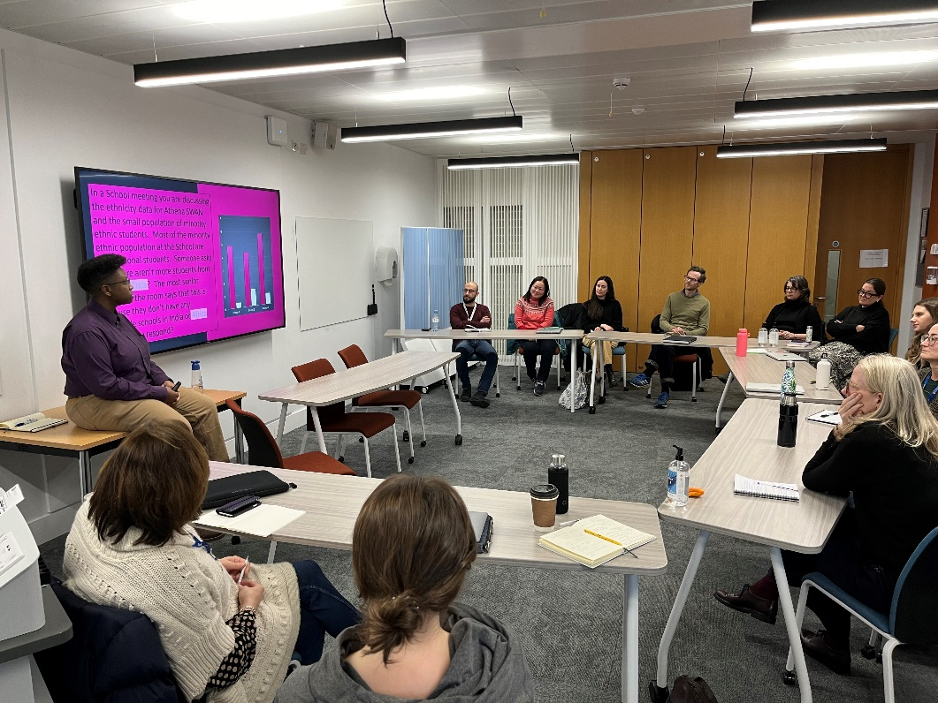
  - Figure 3.1: SAH Cultural Awareness and Sensitivity workshop in January 2024

Research Environment
Equality and inclusion were fully taken into account in the School's submission for REF2021, which was ranked second (Unit of Assessment 32: Art and Design: History, Practice and Theory). All REF-eligible staff were involved in the appraisal process that informed the final selection of outputs. The Director of Research attended training sessions on the code of practice. The School and the institutional REF committee took EDI fully into account in terms of individual reports on personal situations affecting outputs.

Research visitors and exchanges:
We have built new relationships and established ongoing dialogues by bringing people to St Andrews as seminar speakers, conference delegates, workshop participants, visiting fellows, and artists-in-residence. After pandemic restrictions were lifted in 2022, we welcomed an early-career global fellow from the University of Hong Kong. Leveraging the University’s new Global Fellows scheme, we hosted prominent women researchers including from Makerere University, Uganda, The Harvard University Center for Italian Renaissance Studies (Florence and University of Dresden) and the University of Sydney. We have hosted two post-doctoral fellows working on gender equality and queer interpretations in Art History. Two Fellowships starting in 2024-5 will examine colonial legacies in Art History and environmental transformation.

Lectures and conferences:
Each year the School hosts the Octavia Elfrida Saunders Memorial Lecture, delivered by an academic or artist of international stature, and the Museum Galleries and Collections Institute annual lecture invites a distinguished speaker in the museum field. Our research lecture series brings 10 scholars and artists to St Andrews each year, virtually or in person (Tables 13.1 and 13.2, Appendix 2). The organisers of our research lecture series ensure gender balance in the speaker roster and invite speakers whose work diversifies the discipline.

Diverse Teaching
Since summer 2020, the Committee for the Development and Diversification of the Curriculum (CDDC) has reviewed and advised on course materials and bibliographies to reflect histories of colonisation, empire, and the artistic traditions of BAME groups in Western art. Events from this process include the webinar ‘Decolonising the Curriculum in Museum and Heritage Studies’ (April 2021), featuring international speakers from seven countries, and the LGBTQ History Lightning Presentations, organised with the School of History.
“[…] lecturers are diverse and represent a range of backgrounds and perspective, and the curriculum appears to be working to put focus on including art from diverse communities.”
(Woman student, 2022 EDI Survey)
As an outcome of the CDDC process, the School’s first Teaching Away Day was held in 2022. This teaching-focused review session, alongside the established Research Away Day, has continued in 2023 and 2024, providing a regular space to discuss curriculum diversity and encourage self-reflection on teaching. Staff participated in the Inclusive Curriculum Audit (February 2021) and the Cultural Awareness and Sensitivity workshop (January 2024).

Intersectionality:
The increasing diversity of backgrounds and personal characteristics we see in our staff and student population means that we have an increasing proportion of our community who may experience intersectional inequalities, and we are mindful of this in our work. Ensuring the representation of women, LGBTQ+ artists, and BAME artists in our teaching is a priority. Highlighted as an example of Good Practice in Inclusive and Anticolonial teaching, the School has reformed its curriculum by co-designing first-year modules with student feedback. We have strengthened our expertise in medieval, early modern European, and global 20th-21st century art, while developing new specialisms in Middle Eastern, Caribbean, Latin American, and African art. Reading lists are revised annually to include works by global scholars, ensuring strong representation of female authors. Feminist, LGBTQ+, and post-colonial theories are integral to sub-Honours modules and compulsory in ‘Approaches to Art History’. These approaches are core to Honours modules and discussed further in Section 2. Research talks and student-led projects address intersectionality, such as the ‘Visual AIDS Day With(out) Art Film Screening’ (2023), the inaugural Artist in Conversation with Everlyn Nicodemus, and Life Writings by Women Artists. Recent student-led initiatives include ‘Researching Queer, Trans, and Feminist Approaches to Art’ (2024) and the exhibition ‘Say No! Art, Activism, and Feminist Refusal’ with the Wardlaw Museum.


  - Figure 3.2: Poster of the event ‘Visual AIDS Day With(out) Art Film Screening: Everyone I Know Is Sick’ (December 2023)


  - Figure 3.3: Poster of the LGBTQ History Lightning Presentations event, in partnership with the School of History (February 2024)

Staff recruitment, development, career progression and support
As a result of recent hires and addressing areas needing diversification (identified by the CDDC), the School appointed new colleagues (female and male), enhancing diversity in expertise and cultural backgrounds: including specialists in Iranian Islamic Art History, Asian-European artistic encounters, Contemporary Art History in Asia, the Middle East & North Africa and Environmental Art History and staff bringing discipline expertise from Brazil and Turkey. These hires have improved gender balance among staff (Tables 3.1, 3.2 and 3.3, Appendix 2).
Following nearly a decade of male Heads of School (2010–2019), the School of Art History has had two female Heads since 2019. As detailed in Section 2, this reflects career progression improvements within the School, fostering an environment where female achievements are nurtured and celebrated. In the last five years, the School has supported women through mentorship, teaching, fostering research, and encouraging participation in conferences and publications. Textual responses from our EDI Survey highlight this progress:
“The Head of School and members of staff in different career levels are extremely support in terms of career progression.”
(Woman staff, EDI Survey 2024)
Grant success is an essential part of career progression. The School actively encourages bids for external funding. The Director of Research and Director of Impact and Innovation provide support and feedback to all researchers developing grant proposals, through one-on-one feedback as well as once per semester group workshops. Researchers working on projects aligned with the School’s diversification goals have made the following successful bids for external and internal grants:
- Shared Island Stories Between Scotland and the Caribbean: Past, Present and Future (2022-27), UKRI
- Beyond the Feudal Fog: Art and Revolution in Ethiopia (2022-23), Leverhulme Research Fellowship
- From Dar to Dunoon: Rural Scotland and the global reach of African modernist art, Royal Society of Edinburgh Research Fellowship
- EDGES: Entangling Indigenous Knowledges in Universities (2024-27), UKRI (EU) MSCA Staff Exchanges grant.
- LGBTQ+ Artchive: Cataloguing with Community (2024-25), Main Impact and Innovation Fund, St Andrews
- Using Creative Heritage Practice to give Voices to Marginalized Community Heritages (2024-25), Main Impact and Innovation Fund, St Andrews.
New staff are supported through probation by the Head of School and through the School’s internal mentoring scheme as well as university-wide mentoring and professional development schemes, including schemes for female members of staff include Aurora (Advance HE) and the Elizabeth Garrett Mentoring Scheme (University), and schemes for minority ethnic groups include Diversifying Leadership (Advance HE).

Access to information
Equality and ease of access to information about school policies facilitates transparency and encourages inclusion as well as career progression. The Handbook revision and its publication on the School of Art History website in spring 2022 have made information on School policies easily accessible in a single place. As indicated in our 2024 EDI Survey, the handbook is a useful point of reference for all staff; it is especially helpful for integrating new members of staff into the School.

2. Key priorities for future action
We have identified five action priorities to promote gender and intersectional equality in the School. These are based on issues arising from the EDI Survey 2024; the School’s self-assessment; reflection on progress made in the Action Plan Evaluation (see Section 2); analysis of collated data sets; review of the School strategic and operational plans; and discussion in EDI Committee and Management Committee.

Priority 1: Promoting staff and student diversity
Since 2019, the School has been highly successful in championing women’s careers (for instance, increasing to 83% female professors), and the promotion of staff and student diversity remains a key priority. Our success in gender equality enables us to adopt an intersectional approach that is mindful of the ways gender equality intersects with equality based on race, sexuality, disability, and socio-economic background. Across all cohorts, we will continue to work to increase socio-economic and racial diversity in the School of Art History community.
Baseline for improvement:
  - 54% of male respondents, 32% of female respondents, and 57% of “redacted” respondents agree the School has a good balance of diversity among students
  - 64% of male respondents, 47% of female respondents, and 54% of “redacted” respondents agree the School has a good balance of diversity among staff
  - Gender disparity in survey responses suggest perception of diversity is intersectional in nature
  - Self-assessment and Action Plan evaluation identify socio-economic equality and disability as future areas for action.
Action Plan:
- Actions 1.1.1-1.1.5: Expansion of the diversity in terms of gender and intersectionality of our curriculum at all levels in terms of scope, pedagogical approaches, teaching staff, and guest speakers.
- Actions 1.2.1-1.2.5: Improve disability support, especially for staff and postgraduate research students.
- Actions 1.3.1-1.3.5: Examine and investigate intersection of gender and socio-economic diversity at the intake level of the UG cohort; use insight from this investigation to improve gender diversity in UG cohort.
- Actions 1.4.1-1.4.3: Address socio-economic inequalities amongst our current students and how these intersect with gender.
- Actions 1.5.1-1.5.2: Continue to expand our global profile through collaborations and outreach, while ensuring that EDI principles and, especially, gender equality, underpin these efforts.

Priority 2: Facilitating an inclusive environment for all
Providing an inclusive and supportive environment for all is a priority. We want students and staff of all genders to feel supported and to have a sense of belonging in the School, and for prospective students and staff to be able to visualise this and feel welcome (this links to Priority 1).
Baseline for improvement:
- 83% of male staff, 86% of female staff, and 100% of “redacted” staff agree their contributions are valued, a level we are proud of and are committed to maintain;
- From free-text feedback in the survey and through conversations with staff and students, we recognise that the inclusivity of School social events can be strengthened;
- 60% of male students and 50% of male staff do not agree that there are strong role models for them in the School.
Action Plan:
- Actions 2.1.1-2.1.4: Continue to promote and encourage the understanding of LGBTQ+ lives and themes in the School.
- Actions 2.2.1-2.2.2: Develop an inclusive approach, mindful of gender equality, to religious holidays and other significant annual events.
- Actions 2.3.1-2.3.4: To encourage gender equality and community building, increase inclusivity of School social events for academic staff, professional services staff, and students.
- Actions 2.4.1-2.4.5: Promote a positive and inclusive model of leadership that will encourage gender equality in leadership positions in the School.
- Actions 2.5.1-2.5.4: Ensure the School’s online presence reflects the inclusive community that we foster, including our commitment to gender equality.

Priority 3: Promoting well-being and work-life balance
We will continue to promote a healthy work-life balance for staff and students. We continue to adopt a well-being lens when reviewing staff and student policies.
Baseline for improvement:
  - 33% of male staff, 81% of female staff, and 50% of “redacted” staff agree with the statement ‘I am confident that the School would be supportive if I requested maternity/paternity/adoption or other parental leave’;
  - 67% of male staff and 75% of female staff agree that their mental health and well-being are supported in the School;
  - Quantitative survey responses, self-assessment and conversations in the Management Committee demonstrate that work-life balance requires continuous monitoring and can be further improved.
Action Plan:
- Actions 3.1.1-3.1.2: Through consistent monitoring and feedback gathering improve communication about staff workload allocation as well as understanding of how the workload model can reflect principles of gender equality.
- Actions 3.2.1-3.2.2: Promote the role of the Wellbeing Officer as a point of contact for staff and students.
- Actions 3.3.1-3.3.3: Committed, focussed campaigning for a School building adequate from an EDI and well-being perspective, i.e. accessible premises that offer sufficient space for all, including for carers and commuters.
- Actions 3.4.1-3.4.3: Promote gender equality by encouraging staff to take up their full Annual Leave allowance and to make full use of other types of Leave as and when required.
- Actions 3.5.1-3.5.2: Improve work-life balance and foster gender equality by further promoting and facilitating flexible working.

Priority 4: Supporting and encouraging academic and PS staff and student career progression
Promoting the career progression of female academic staff and ending precarity for staff on fixed-term contracts, especially education-focused staff, often women, are two of the success stories supporting our application for a Silver award. However, we recognise the need to continue to monitor and support all staff, academic and professional services, towards this end. Furthermore, we will continue to improve out insight into how career progression interacts with intersectional issues (especially sexuality, disability, and race).
Baseline for improvement:
  - We are proud that 100% of staff of all genders agrees that their line manager supports their career progression. We aim to keep this level of satisfaction at 90% or above;
  - 40 % of male staff and 53% of female staff agree that the School induction process at the beginning of their current role was a useful activity;
  - 40% of male staff and 44% of female staff are not satisfied with the guidance received from the School on promotion procedures.
Action Plan:
- Actions 4.1.1-4.1.5: Enhance support for mid-career and senior academic staff in the broader context of the School’s commitment to gender equality..
- Actions 4.1.1-4.1.5 and 4.2.1: Enhance the support for early career scholars and fixed-term staff, who are more likely to be women.
- Actions 4.3.1-4.3.2: Investigate ways to support staff careers with a view to intersectionality.
- Actions 4.4.1-4.4.2: Enhance the employability of our PGR students in a way that is mindful of gender equality.
- Action 4.5.1: Support career development of Professional Services Staff.

Priority 5: Building culture, community and trust
The 2024 EDI survey shows that both students and staff recognise EDI as a priority for the School. However, the survey also suggests inconsistency in awareness and understanding of work on gender and intersectional equality among our students, with some students having less awareness of EDI work at School and University level. Furthermore, survey responses of both students and staff suggest that bullying and harassment support can be improved and better advertised.

Baseline for improvement:
  - While the vast majority of staff agree that EDI are a priority in the School, part of our students have a different perception: 80% of male students, 75% of female students, and 77% of “redacted” students agree with the statement;
  - 50% of male staff, 69% of female staff, and no-one among “redacted” staff express satisfaction with the way bullying and harassment are addressed in the School;
  - Students of all genders express notably less satisfaction: 40% male students, 49% female students, and 40% “redacted” students agree they are satisfied. Large percentages of students of all genders neither agree nor disagree, which suggests not only that bullying and harassment support for our students can be improved, but also that the support we already offer can be communicated more effectively.
Action Plan:
- Actions 5.1.1-5.1.3: Improve and extend the range of gender equality and other EDI training offered within the School to both students and staff, with at least one event per year focused on gender equality and intersectionality.
- Actions 5.2.1-5.2.3: Improve communication about our Athena Swan and other EDI initiatives, and provision of both educational materials and key EDI policies for use by staff and students.
- Actions 5.3.1-5.3.2: Increase student participation in the School’s EDI work.
- Actions 5.4.1-5.4.3: Enhance the School’s culture of zero tolerance towards bullying and harassment.
- Actions 5.5.1-5.5.3: Increase staff and student engagement with EDI surveys.
- Actions 5.6.1-5.6.2: Embed systematic review into the School’s gender equality work.

Section 4: Future Action Plan

1. Action plan
22 May 2025 iteration
This revised version was approved by the School of Art History Management Committee on 22 May 2025.
The following considerations have guided the timeframe for the priorities and actions outlined below:
- All priorities will see immediate action, beginning in February 2025
- We have identified ‘easy wins’ and have scheduled these also for the months following submission of this application
- Some actions are dependent upon the successful completion of others; other actions are continuous.
The roles with overall responsibility for the delivery of the actions are:
HoS | 1.1.3; 1.1.4; 1.2.2; 1.3.4; 1.5.1; 2.2.2; 2.3.1; 2.4.1; 2.4.3; 2.4.4; 3.3.1; 3.3.2; 3.4.2; 3.5.2; 4.1.2; 4.1.4; 4.1.5; 4.2.1; 5.4.3;
DoEDI* | 1.1.2; 2.1.4; 2.2.1; 2.4.2; 2.4.5; 2.5.1; 2.5.3; 2.5.4; 3.2.1; 3.3.3; 3.4.3; 4.1.1; 4.3.1; 4.3.2; 5.1.1; 5.1.3; 5.2.2; 5.2.3; 5.3.1; 5.3.2; 5.5.1; 5.5.2; 5.5.3; 5.6.1; 5.6.2
DoR | 1.1.5; 2.1.2; 4.4.2;
DoT | 1.2.5; 3.4.1
DoPGR | 2.5.2; 4.4.1;
CDDC Chair | 1.1.1; 2.1.1; 2.1.3
Admissions Officer | 1.3.1; 1.3.2; 1.3.3; 1.3.5; 1.4.1; 1.4.2; 1.4.3
Disability Officer | 1.2.1; 1.2.3; 1.2.4
Social Officer | 2.3.2; 2.3.3; 2.3.4
Wellbeing Officer | 3.2.2
School Research Coordinator | 1.5.2
School Manager | 3.1.1; 3.1.2; 3.5.1; 4.1.3; 5.1.2; 5.2.1; 5.4.1; 5.4.2
School Coordinator | 4.5.1
* Actions where DoEDI will also be responsible for implementing the action (in addition to overseeing delivery) are underlined
Outline overall schedule for implementation of actions.
Priority | Action No. | 2025 | 2026 |  | 2027 |  | 2028 |  | 2029 |  | 2030
1 | 1.1
 | 1.2
 | 1.3
 | 1.4
2 | 2.1
 | 2.2
 | 2.3
 | 2.4
 | 2.5
3 | 3.1
 | 3.2
 | 3.3
 | 3.4
 | 3.5
4 | 4.1
 | 4.2
 | 4.3
 | 4.4
 | 4.5
5 | 5.1
 | 5.2
 | 5.3
 | 5.4
 | 5.5
 | 5.6
Dark colour indicates activity related to delivery of actions. Pale colour indicates ongoing work.

Priority 1: Promoting staff and student diversity
No. | Objective | Rationale | Action | Responsibility  (oversight, implementation) | Timeline | Outputs and Outcomes
1.1 | Expansion of the diversity in terms of gender and intersectionality of our curriculum at all levels in terms of scope, pedagogical approaches, teaching staff, and guest speakers. | Dedicated collective efforts to continually strive towards curriculum diversification. As our EDI Survey responses demonstrated, while students and staff recognise diversity in the curriculum, there is substantial scope for improvement as to the perceived balance of gender and intersectional diversity within the School – in terms of students, staff and decision makers.
1.1.1 |  | Membership of CDDC has previously fallen exclusively on female staff; EDI work needs to be recognised and balanced to not affect one gender disproportionally. | Build on the previous work of the Committee for the Development and Diversification of the Curriculum (CDDC) in a sustainable way  by giving workload acknowledgement and  by managing the scope of the work by identifying annual theme (i.e. LGBTQ+ and gender identities, anti-racism and gender, to name a few). | Chair of CDDC and committee members | New CDDC in place by Sep 2025;  Workload recognition agreed with HoS and MC by Sep 2025;  Annual scope 2025-  2026 LGBTQ+ and  gender identities: see also Action 2.1.1 Thereafter, annually. | Output: Workload recognition to the members of CDDC; at least one male staff member to serve on CDDC by September 2025 (baseline: 100% women); new curriculum changes and updates implemented.  Outcome: At least 75% of respondents in 2028 survey agree that the "course curriculum is representative of a diverse range of perspectives" (baseline = 70% 2024 survey)
1.1.2 |  |  | Assess the need for additional teaching resources for staff focused on gender diversity and intersectionality (i.e. Disability toolkit; a toolkit for Cultural Awareness, etc.). Identify such toolkits in pre-existing resources (UKRI, University EDI resources) and provide links in staff handbook. | DoEDI, DO, CDDC, L&TC | DoEDI to discuss in School L & TC semester 2 2025-  2026;  Discussion in School Teaching Away Day May/June 2026;  CDDC meeting in June 2026 | Outcome: At least 75% of respondents in 2028 survey agree with the statement “I am supported in efforts to incorporate intersectionality and gender equality principles in my teaching and curricular development.” (new question, no baseline)
1.1.3 |  |  | When recruiting new staff, maintain measures developed in the Athena Swan Cycle 2019-2024 to foster gender and intersectional diversity, chiefly completion of unconscious bias training required for all staff and PGR students participating in selection process. Evaluate regularly to make improvements and respond to feedback. | Overseeing measures: Chair of Hiring Committee (normally, but not always HoS);  Evaluation: School Manager and HoS | Every recruitment cycle;  Evaluation annually in the summer, beginning June 2025 | Outcome: maintain baseline of 100% completion of Unconscious Bias Training for staff and PGR participating in recruitment process - both attending post-interview discussions and serving on hiring committee.
1.1.4 |  |  | In collaboration with HR,  investigate strategies(giving consideration to potential gendered impacts of proposed strategies) to enhance diverse staff recruitment, particularly to eliminate barriers for candidates from outside Europe/North-America. Measures may include circulating interview questions in advance; in the interviews, include questions on how to take EDI approach in teaching, among others. | HoS; EDI committee; HR; Chairs of Hiring Committees | June 2026 | Output: New measures to be implemented for recruitment processes from Sep 2026 onwards.  Outcome: Hiring committee chairs agree that recruitment shortlisting and appointment processes are inclusive (assessed in focus group for hiring committee chairs in Sep 2028).
1.1.5 |  |  | Amplify minoritised voices and work towards further gender and intersectional diversity in our guest speakers. | DoR, Research Lectures organisers | Ongoing | Outcome: Staff and students of diverse genders have improved experience of representation. By 2028, target of 75% (F) and 50% (M) (baseline: 63% women, 20% men in 2024 survey) for students and staff who agree that the School has a good balance of diversity among its guest speakers.
1.2 | Improve disability support, especially for staff and postgraduate research students. | A diverse School requires that no groups are systematically excluded because of disability. Some of the responses in our EDI surveys show that some students and staff feel that the School could improve support for disability. We strive to embed disability support in the culture of the School, but we currently have little insight into how disability intersects with gender in our community.
1.2.1 |  |  | Hold a disability focus group facilitated by central EDI team within the School representing diverse disabilities; examine barriers experienced by disabled staff and students and how these intersect with gender. | DO; EDI  committee | Focus group convened by October 2025, possibly led by Kathryn Herschell; work completed by Mar 2026. | Output: Report on focus group insights authored by DO by Mar 2026 is passed to newly formed Disability Working Group (DWG) so as to underpin the DWG agenda for actions.
1.2.2 |  |  | Create structure for disability working group (disability officer, well- being officer, DoEDI focus group representative, and student class reps) to formulate and implement measures based on areas for improvement identified by the focus group. | HoS, DO; MC | WG established in Apr 2026; measures implemented by Dec 2027. | Output: Disability Working Group is established and meets regularly at least once per semester.  At least two measures improving disability support in place by end of 2027.  Promotional campaign run in February 2028 by Social Media Officer to raise awareness of the commitment the School has made to support disabled staff/students; campaign to highlight the two measures taken (above).  Outcome: At least 65% of disabled respondents agree that “Equality, diversity and inclusion are a priority within the School” in 2028 EDI survey (baseline 44% disabled staﬀ and student respondents: 86% of respondents who don’t consider themselves to be disabled, 2024 EDI Survey).
1.2.3 |  |  | Consult and collaborate with the central EDI team, HR, student disability services, and staff and student networks to achieve the goals of the disability working group. | DO, Disability working group | Apr 2026-Dec 2027 | Output: Disability WG chair gives a presentation at University EDI Directors meeting outlining the work of the group and the actions it has taken. As a result, work of the disability working group is integrated with wider University gender equality and disability work.
1.2.4 |  |  | Assess training needs regarding disabilities, and integrate learning opportunities on disabilities within wider training opportunities fostering gender equality, understanding these as part of our professional skills embedded in an inclusive School culture. | DO, Disability working group | Needs assessed by Jun 2026; first training offered in 2026-2027; from then on annually | Output: To maintain baseline of at least one training event per year focused on disabilities and its intersection with gender offered to staff and students.
1.2.5 |  |  | Require that module handbooks meet digital accessibility criteria as laid out in the Moodle course “digital accessibility basics,” which all staff shall be required to take. | Module coordinators overseen by DoT | By start of academic year 2025-26. | Outcome: 100% of module handbooks (baseline ~60%) meet digital accessibility criteria as laid out in the Moodle course “digital accessibility basics.” 75% positive response in Student and Staff Surveys by 2028 to statement “The School embeds equality, diversity and inclusion in its learning, teaching and assessment practices” (new survey question, no baseline).
1.3 | Examine and investigate intersection of gender and socio-economic diversity at the intake level of the UG cohort; use insight from this investigation to improve gender diversity in UG cohort. | From the implementation of our previous Action Plan the SAT has identified the need to continue work on enhancing gender equality in our UG student cohort. In particular, we have insufficient data regarding the intersection of gender and socio- economic equality at the intake stage.
1.3.1 |  |  | Collect and analyse Admissions data(Visiting Day participation, applications, offers made, acceptances, entrances) split by gender and socio- economic background. | Admissions Officer | Oct-Nov 2025; data collected from2021-2022 to 2024-2025  To be repeated in autumn 2029 for years 2025-2026 to 2028-2029 to assess effects of measures | Output: Report with data analysis to be authored by Admissions Officer and to be presented and discussed at School Council by April 2026.  Outcome: Increased insight into intersection of gender and socio-economic equality among our UG entrants, which we can build upon in next AS cycle.
1.3.2 |  |  | Compile overview of state-school outreach activities already taking place in the School and identify gaps and areas to improve. | School Office, Admissions Officer | Overview completed by Jan 2026 | Output: Overview with activities and areas for improvement to be authored by Admissions Officer and to be presented and discussed at School Council by Feb 2026. Plan to be determined for addressing agreed upon gaps.
1.3.3 |  |  | Review and update presentation materials used at Visiting Days encouraging applications that are more diverse in terms of gender and socio-economic background. | Admissions Officer in consultation with DoEDI | Jun-Jul 2026; annual summer review and update thereafter | Output: Reviewed and updated presentation materials to be circulated to all staff by Jul 2026.
1.3.4 |  |  | Bring together a pool of colleagues interested in outreach and Visiting Day work. Recognise their activities in the workload allocation model. Encourage membership from those with lived experience of a range of backgrounds and circumstances and ensure membership is gender balanced. | Admissions Officer, overseen by HoS | Pool formed by Jun 2026; workload recognition allocated from 2026-2027 | Outcome: Enhanced gender and socio-economic diversity of representation at SAH Visiting Day and outreach events.
1.3.5 |  |  | Collaborate with other Schools in the organisation of local school visits building on their experience attracting male students (e.g. Physics and Astronomy, Computer Science). | Outreach and Visiting Day pool and Admissions Officer. | Initial meeting with interested Schools who experience a reverse gender imbalance to establish workability and begin planning by Oct 2026 | Output: One school visit per year in collaboration with other Schools that have a dominantly male UG cohort.  Changes made to AH outreach practice in accordance with lessons learned from collaboration with the other Schools.  Outcome: Enhanced understanding in SAH of recruiting male UG students; sharing of best practices in attracting female students.
1.4 | Address socio-economic inequalities amongst our current students and how these intersect with gender. | Qualitative responses from students showed that some feel excluded from events and activities due to socio-economic inequalities. We want to support students of all socio- economic backgrounds and genders to thrive within our community.
1.4.1 |  | The timing of this initiative has been adjusted to accommodate workload across the School. | Hold a focus group with students with state- school backgrounds (and overseas equivalents) to investigate challenges and formulate potential actions. The focus group is gender balanced as it reflects the overall gender distribution of our student population. | EDI committee; Admissions Officer | Focus group created by Oct 2026; work to take place Nov 2026-Mar 2027;  reporting on findings Apr-Jun 2027. | Output: Focus group to be held during 2026. Report authored by Admissions Officer to be distributed to all staff by June 2027.
1.4.2 |  |  | Liaise with Admissions and central EDI team to develop an integrated approach to supporting state-school students in Art History. | Admissions Officer | First meetings to happen in Autumn 2026, second set of meetings in Spring 2027 | Output: see 1.4.3.
1.4.3 |  |  | Use findings from focus group and meetings with Admissions and central EDI team to draw up a list of recommended actions to enhance the inclusion of students with state-school backgrounds. | EDI committee; Admissions Officer | List of recommended actions completed by July 2027; implementation during academic year 2027-2028. | Output: List of recommended actions to enhance the inclusion of students with state-school backgrounds in SAH.  Outcome: Students from all socio-economic backgrounds and genders feel included in SAH as evidenced by positive qualitative feedback in EDI  surveys.
1.5 | Continue to expand our global profile through collaborations and outreach, while ensuring that EDI principles and, especially, gender equality, underpin these efforts. | International collaborations bring geographic, socio-economic, and cultural diversity to SAH. To create an inclusive, international community, we must continue to be mindful of maintaining a focus on gender equality throughout these collaborations.
1.5.1 |  | These searches are in effect recruitment avenues; postdoctoral Early Career Fellows and Global Fellows are treated as part of the staff for the time that they are with the School. Principles upheld in recruitment should therefore be extended to these searches as well. | Formulate and implement SAH policy mandating that all members of the selection committees of 1) postdoctoral nominees for competitive fellowships (Leverhulme Early Career Fellowship, British Academy Early Career Fellowship) and 2) Global Fellows, shall be required to take Unconscious Bias training, as in School Recruitment practices. | DoR; School Research Coordinator; MC; overseen by HoS | Policy formulated, discussed in MC, and implemented by Dec 2025; to be re-evaluated in summer 2028. | Outcome: all members of selection committees for postdoctoral nominees and Global Fellows will have completed Unconscious Bias Training.
1.5.2 |  |  | Continue to pursue partnerships and MoUs with universities in Latin America, Africa, and Asia. All new MoUs will include language specifying our commitment to gender equality, which may not be an underpinning principle at collaborating institutions | HoS, DoR, DoPGR, School Research Coordinator | At least one new partnership proposed by 2025-26, in place by 2027. | Output: Have at least one new partnership with institutions from Latin America, Africa, and Asia in place by 2027; all new MoUS from 2025-2026 onwards include language specifying our commitment to gender equality.

Priority 2: Facilitating an inclusive environment for all
No. | Objective | Rationale | Action | Responsibility  (oversight, implementation) | Timeline | Outputs and Outcomes
2.1 | Continue to promote and encourage the understanding of LGBTQ+ lives and themes in the School. | Our Student and Staff Surveys evidence needs  from students to increase LGBTQ+ visibility and representation in the School. In addition, some of our students and staff don’t feel that they have role models within the School. We want SAH to be a welcoming environment for all the gender identities included in LGBTQ+. We define gender equality as the equal opportunity for people of all genders to reach their full potential
2.1.1 |  |  | Through the CDDC, embed LGBTQ+ content in the curriculum (see also 1.1.1). | CDDC Chair, CDDC | New CDDC in place by Sep 2025;  opportunities for including LGBTQ+  themes and perspectives in the curriculum identified by Apr 2026;  discussed with all academic staff at Teaching Away Day in May/June 2026. | Output: Proposed changes in specific modules will be discussed under the leadership of CDDC in a workshop for all academic staff during the Teaching Away Day in May 2026. Content involving LGBTQ+ themes is embedded in the curriculum from year 2026-27.  Outcome: The SAH curriculum at all levels will have greater LGBTQ+ representation.
2.1.2 |  |  | Continue to organise LGBTQ+ themed events such as research lectures and participation in LGBTQ+ History Month. | School President; EDI committee; DoR; Research Lectures Convenors. | One LGBTQ+-  themed event per semester, starting Feb 2025 | Output: The LGBTQ+ History Month event is held every year in February, and the School organises at least 1 more research lecture per year on related themes.  Outcome: Target survey response: at least 75% (with less than 5% difference between heterosexual and others) of all students agree “There are strong role models for me within the School.” (2024 baseline: heterosexual students 76% positive, all other students 63% positive)
2.1.3 |  |  | Create a new team- taught Honours module on LGBTQ+ Art and Heritage. | CDDC and MHS staff with the support of the DoT. | Module to be approved by CAG by Feb 2027. | Output: Module is created and starts running from 2027-28.  Outcome: The SAH curriculum at all levels will have greater LGBTQ+ representation, improving the experience of students of all genders.
2.1.4 |  |  | Support and participate in St Andrews Pride. | DoEDI, School President | Annually in April. | Output: Continuous support is provided by SAH to the organisation of St Andrews Pride by Saints LGBT.  Outcome: Through visible support of St Andrews Pride from SAH, our students of all genders feel better represented.
2.2 | Develop an inclusive approach, mindful of gender equality, to religious holidays and other significant annual events. | Based on quantitative data from our Student and Staff Surveys, some students do not agree that the social activities within the School are welcoming to all.
2.2.1 |  | Requests for the recognition for a greater plurality of religious holidays have been received by the School Office in recent years. The University is currently working on a Religious Observance Policy, where the School will be able to find guidance on relevant dates and festivities. | Create a School EDI calendar with diverse (religious) holidays and other significant  events (International Women’s Day, Black History Month, etc.) using examples published by University and make it available to all students and staff.  Through discussions with staff and students, determine the way that religious holidays affect gender identities  differently. | DoEDI; EDI  committee | Draft calendar  Jun 2026;  calendar implemented by Sep 2026. | Output: Calendar to be created and circulated by Sep 2026, aligned with University’s Religious Holidays and Festivals Calendar. Output: Have a SSCC meeting (Sem 2, 2025-26) dedicated to receiving student input regarding the calendar (to inform 2.2.2).
2.2.2 |  |  | Create a School policy, mindful of different gender identities, that allows colleagues to rearrange teaching and other duties to allow people of different denominations the flexibility they need to celebrate and publicise this via email and in the Staff Handbook. | HoS; School Manager; MC | Preparation Feb-Apr 2026, incl. discussion in MC; policy fully implemented by Sep 2026. | Output: Policy is implemented and incorporated into the School Handbook.  Outcome: SAH supports staff of all religious denominations to celebrate, and this support is offered equally to all genders.
2.3 | To encourage gender equality and community building, increase inclusivity of School social events for academic staff, professional  services staff, and students. | Survey respondents reported limited non-alcoholic options and event location as barriers to participation, with particular comments from parents regarding timing of events. Social events build relationships and community amongst staff and students from diverse background and of different gender identities; these exchanges can foster inclusion, acceptance, and awareness.
2.3.1 |  |  | Appoint a Social Officer from the academic staff to collaborate with School Office staff on the organisation of social events and include this role holder on the EDI committee. | HoS | Consultation with the MC during Sep-Dec 2025;  implementation of the new role by Jan 2026. | Output: SAH Social Officer in post from semester 2, 2025-26.  Outcome: Organising social events and supporting students in their social events becomes a workload-acknowledged role which is integrated with the School’s EDI work.
2.3.2 |  |  | Continue to integrate social events into the School calendar. Semesterly programme of social events are set and timings communicated at the start of each semester (along with other School events and meetings that are already routinely added to the School calendar). | Social Officer; School Office | Ongoing | Output: All staff and students have information on timing of events well in advance.  Outcome: SAH social events are communicated as forming an integral part of our inclusive School culture.
2.3.3 |  |  | Hold a focus group with a diverse representation of students in terms of gender and other protected characteristics to examine how we can make social events more appealing and inclusive to our diverse student body. | Social Officer | Focus group created by Feb 2026; work to take place Mar- May 2026;  reporting on findings Jun- Jul 2026. | Output: Report with recommendations for School social events to be discussed at School Council September 2026 and to be implemented in academic year 2026-27.  Outcome: Target of at least 75% students (all genders) agree in 2028 survey that “The School’s social events are welcoming to all” (2024 baseline 80% M, 68% F, 39% respondents who did not identify as either M or F or opted not to give a gender identity).
2.3.4 |  |  | Examine, through informal conversations and invitations to staff, ways to make School social events more varied and inclusive. | Social Officer | Throughout 2026, at School Council, via email invitation, and informally. | Outcome: Target of at least 75% of student and staff respondents (all genders) in 2028 survey agree that “The School’s social events are welcoming to all” (2024 baseline 91% M, 69% F, 43% respondents who did not identify as either M or F or opted not to give a gender identity)
2.4 | Promote a positive and inclusive model of leadership that will encourage gender equality in leadership positions in the School. | 50% of male members of staff, in responses to our 2024 Survey, do not agree that there are role models for them in the School. In order to improve diversity and gender equality at leadership levels, all individuals in the school must have access to the same resources encouraging excellence. |  |  |  | Outcome: Target of ~60% of male staff agree in 2028 survey that there are strong role models within the School (baseline 2024  ~50%; baseline for female staff was already 88% in 2024).
2.4.1 |  |  | Maintain and enhance the School’s mentorship programme for new hires by creating guidelines for mentoring partnerships, including on expected duration, discussing these in School Council, and distributing them to all academic staff. | HoS with MC; School Council | Guidelines drafted summer 2026; discussion in MC and SC Sep-Nov 2026; implementation Jan 2027 | Output: Guidelines for School mentoring programme to be published in Staff Handbook and implemented by Jan 2027.
2.4.2 |  |  | Promote workshops for career development involving senior members of staff and thereby foster the exchange of experiences between colleagues at different career stages. | DoEDI; HoS; DoR; DoI; DoT; overseen by DoEDI | At least one workshop per semester, starting Feb 2026. | Output: Organisation of at least one workshop promoting career development per semester, with short questionnaires sent to participating staff by School Office to measure satisfaction.  Outcome: 75% of staff find career development workshops helpful.
2.4.3 |  |  | Maintain and enhance mentoring for Professional Services staff within the School and consult the University on this topic. | HoS; School Coordinator | Consultation 2025-26 and any resulting improvements implemented by Sep 2026. | Output: Improvements made on the mentoring system for Professional Services Staff by Sep 2026.  Outcome: In ARD meetings of PSS 2026-27, target of 75% express satisfaction with mentoring arrangements.
2.4.4 |  |  | Continue to increase awareness of mentoring programmes for all staff through ARD meetings, emails, and induction for new staff (see also 4.2.1). | HoS; line managers (when not the HoS) | Annual email from HoS in September; annually in ARD meetings; during new staff induction (usually Sep, Jan). | Outcome: EDI surveys indicate that at least 75% of male and female respondents are aware of mentoring programmes.
2.4.5 |  |  | Hold a focus group with male- identifying staff, led by staff from central EDI team. | Coordinated by DoEDI; central EDI team; EDI committee | DoEDI to liaise with central EDI team in Oct-Nov 2026; invitations for focus group to go out Jan-Feb 2027; focus group meeting in Feb-Mar 2027; report by  May 2027. | Output: Report to be authored by central EDI team discussed by EDI committee and at least 2 recommendations made to MC.  Outcome: Increased insight into hurdles experienced by male staff in finding role models in SAH.  Outcome: Survey target of at least 75% M staff agree “There are strong roles for me within the School” (baseline 2024 survey 50% M / 88% female).
2.5 | Ensure the School’s online presence reflects the inclusive community that we foster, including our commitment to gender equality. | A web presence that accurately reflects our commitment to gender inclusion will help to make all members of the community feel included and represented, which shall foster gender equality.
2.5.1 |  |  | Every two years, update students’ profiles on the School website and empower students to be in charge of the process; ensure that the published profiles reflect the SAH commitment to gender equality by featuring a diversity of gender identities. | Student reps; IT Officer; overseen by DoEDI | Bi-annually, starting in Feb 2026 | Output: Students’ profile page is updated every two years with the support of students’ reps; the published profiles will include a range of gender identities.
2.5.2 |  | As above, a web presence that reflects the School’s pride in its diversity and gender equality will perpetuate these values within the SAH community. | Encourage PGR students to create and update their profiles on the School website. | DoPGR | Annually, starting Sep 2025 | Output: 90% of PGR profiles are updated during the first semester of each year.
2.5.3 |  | Keeping this page up to date and reflective of the School’s most recent efforts will make it clear that EDI and gender equality are a priority in the School. Public affirmations of the School’s commitment to EDI and gender equality will foster an environment in which all members of the School feel supported. | Review the School’s EDI page and actively promote it. | DoEDI; EDI  committee | EDI page review Feb-Jun 2025, then biannually. | Output: A thorough revision of the EDI page is done every two years (next review due 2027), and minor updates are incorporated every year.  Output: Increased number of places we promote the EDI webpages (i.e. at the bottom of any email about EDI and social events, on posters throughout the School building).  Outcome: Increase in number of visitors of EDI webpages (baseline to be established in Feb-Jun 2025, to be measured again in Feb-Jun 2027 and Feb- Jun 2029).
2.5.4 |  | See 2.6.3  rationale. | Further embed EDI in the School’s socials. | Social Media Officer, overseen by DoEDI | Feb-Jun 2025; then annually in Sep-Oct | Outcome: Every start of the academic year, the DoEDI will liaise with the Social Officer to discuss how to embed EDI in the School’s socials.

Priority 3: Promoting well-being and work-life balance
No. | Objective | Rationale | Action | Responsibility  (oversight, implementation) | Timeline | Outputs and Outcomes
3.1 | Through consistent monitoring and feedback gathering improve communication about staff workload allocation as well as understanding of how the workload model can reflect principles of gender equality. | A considerable percentage of staff members don’t feel that they have a good work-life balance, and the workload model needs to be more transparent to all.
3.1.1 |  |  | Establish regular meetings (once per semester) involving the HoS, the School Manager and the DoEDI to evaluate and, where necessary, improve the workload allocation model; these meetings shall respond to any concerns raised during the briefings each semester – see 3.1.2. | School Manager | Starting Autumn 2025; every semester | Output: Workload allocation meetings are routine from Autumn 2025.
3.1.2 |  | Protecting gender equality means understanding that each member of staff may have different needs and requirements for maintaining work-life balance (a full- time carer or a new mother may prefer tasks that allow them to work flexibly, for example). | Offer briefings on workload allocation every semester (instead of annually); include in each of these sessions an opportunity for staff members to respond to the current tenets and structure of the workload model. | School Manager | Starting Feb 2026; every semester | Outcome: Workload model is not “one size fits all,” but adapted to the needs of all the members of the SAH community.  2028 Survey target of 75% M/F agreeing that workload model is transparent (baseline 2024 50% M / 67% F).
3.2 | Promote the role of the Well-Being Officer as a point of contact for staff and students. | Well-being can be an important indicator of a supportive and inclusive School and it is also a key indicator of issues associated with equality. We currently work closely with the Well-Being officer, but they could be more integrated into EDI actions moving forward. |  |  |  | Outcome: an integrated approach to EDI and well-being; well-being resources are embedded within the School community
3.2.1 |  |  | Embed the Well- Being Officer in the EDI committee to enhance synergy between EDI and well-being work. | DoEDI, WBO | Starting Sep 2025 | Output: Well-Being Officer is a member of the EDI committee ex officio.
3.2.2 |  |  | Create an overview of well-being resources for students and staff and make available on the School website and throughout School building, following successful examples from other Schools (i.e. School of History, School of Physics). | WBO | Sep-Dec 2025 | Output: Well-being resources are available on School website and throughout building from January 2026.  Outcome: At least 75% of 2028 survey respondents agree “The school has clear guidance on where to find support around issues such as health, wellbeing and welfare (pastoral support)” (new question, no baseline).
3.3 | Committed, focussed campaigning for a School building adequate from an EDI and well-being perspective, i.e. accessible premises that offer sufficient space for all, including for carers and commuters. | Encouraging gender equality means understanding that each member of staff may have different needs and requirements in relation to the building we work in (e.g. a new mother may need lactation space, a full- time carer may need to commute)
3.3.1 |  |  | Continue to involve DoEDI in discussions on the School’s premises as the University develops its estate in the coming years. | HoS; DoEDI | At least annually | Output: All meetings between HoS and PO about School premises include input from DoEDI.
3.3.2 |  |  | Highlight the need for an adequate and inclusive building in annual Operational Reports and strategic and planning meetings with the Principal’s Office. | HoS; DoEDI; MC | At least annually, from 2025-26 | Outcome: assessment of building inclusivity will inform the annual Operational Reports.
3.3.3 |  | Our current School building is historic, and implementation of our previous Action Plan has taught us it cannot be made wheelchair accessible; we are committed to supporting alternatives. | Continue to encourage the use of accessible spaces when required by students and/or staff | School Office; overseen by DoEDI | Before the start of classes each semester | Output: room allocation in timetabling teaching meets accessibility needs of students and teaching staff.  Output: Staff are encouraged to invite students to meet in an accessible location in their email signatures and/or office hour sign-up forms.
3.4 | Promote gender equality by encouraging staff to take up their full Annual Leave allowance and to make full use of other types of Leave as and when required. | Taking Annual Leave improves work-life balance for all genders and especially women, who tend to have more caring responsibilities. Since AS2019 and the University-wide introduction of an online Annual Leave booking system, it has become much easier for individual staff members to monitor their Annual Leave, and we want to embed it even further in our School culture. |  |  |  | Outcomes: apart from the teaching weeks of each semester, taking up full Annual Leave will be further embedded with the SAH culture. Staff will experience no barriers to using other types of Leave as and when they need it.
3.4.1 |  |  | Ensure important semester dates (marking deadlines, module board meetings, teaching and research away days) are announced before the start of each semester to enable staff to schedule their AL before and after the teaching weeks. | DoT; DoR;  Exam Officer | Before the start of each semester; where possible, at the beginning of each academic year | Output: A School Calendar that contains all essential semester dates at the start of each semester.
3.4.2 |  |  | Enhance communication about the University’s Leave provision, by encouraging staff to take their full AL via annual HoS/WBO emails, in induction for new staff, and in ARD meetings, and by alerting staff to other types of Leave (such as the statutory right to paternal leave) in SC meetings when relevant. | HoS, WBO | Annually, starting Aug 2025 (at beginning of new AL cycle) | Output: HR Business Partner to attend a School Council meeting to outline changes to the special leave policy (in particular carers leave, extended emergency leave) in autumn 2025; to be repeated annually as required.  Output: additional signposting to family leave provision in staff handbook and EDI webpages.  Outcome: Awareness of the breadth of University Leave provision among all staff.
3.4.3 |  |  | Use the EDI Survey to continue monitoring views of staff returning from caring roles and/or career breaks, to assess support, and if more is required. | EDI committee; overseen by DoEDI; School Manager | Staff surveys 2026, 2028 | Outcome: Maintain the portion of staff members who feel supported by the School after returning from caring roles and/or career breaks above 80% in both women and men.
3.5 | Improve work-life balance and foster gender equality by further promoting and facilitating flexible working. | Flexible working fosters gender equality and diversity by recognizing that different gender identities may have different scheduling needs.
3.5.1 |  |  | Include a section in the School Staff Handbook about flexible working policy. | School Office, School Manager | Feb-Jun 2025 | Output: Staff Handbook is updated once a year, and a section about flexible working policy is included by summer 2025.
3.5.2 |  |  | Implement the School’s policy that encourages flexibility around teaching times and office arrival times for PSS to align them with “core working hours” for staff with caring responsibilities. | HoS; DoT; School Manager | Starting Feb 2025 | Outcome: Flexibility around teaching times and office arrival times for PSS are fully embedded within our School culture.  Staff responses to “The School enables flexible working” maintained at >90% in 2026 and 2028 survey.

Priority 4: Supporting and encouraging academic and PS staff and student career progression
No. | Objective | Rationale | Action | Responsibility  (oversight, implementation) | Timeline | Outputs and Outcomes
4.1 | Enhance support for mid-career and senior academic staff in the broader context of the School’s commitment to gender equality. | In the past, SAH has had a majority of male staff in leadership roles (HoS, DoR). This has changed in the past 8 years and our male staff are now less optimistic about the School’s support of career development than our female staff. However, as a School with a majority female staff at mid-career and professorial levels, we have a major role to play in the University’s key priority (University AS Silver application 2024) of increasing representation of women in senior roles. We need to maintain our success in promoting female staff while also increasing satisfaction among male staff. |  |  |  | Outcome: Increase survey percentage of men satisfied with the guidance received from the School when considering promotions procedures (baseline ~60% (M) / 90% (F))  Outcome: Continue to see proportion of promotion applications on par with staff body (baseline: academic staff body 2019-2023 average 69% F, promotion applications 2019-2024 73% F).
4.1.1 |  |  | Embed evaluation of staff career development and gender equality in annual School management cycle. | DoEDI; MC | Every first MC meeting of the academic year, beginning in Sep 2025 | Output: Report based on annual staff changes and promotions in relation to gender authored and presented to MC by DoEDI as basis for discussion and further actions in the year to follow.
4.1.2 |  | The rotation of administrative roles ensures that as many members of staff as possible have an opportunity to serve in leadership positions in the School, thus enhancing applications for promotion for all genders. | Use of rotation system for admin roles to a maximum of 3 years or until the role holder goes on research leave. | HoS with MC | Admin roles reviewed annually Feb- Mar | Output: HoS advertises call for vacant admin roles annually in Feb- Mar; allocation happens following discussion in MC mindful of gender equality (for example, senior leadership roles will go to both men and women).  Outcome: % female members of MC (= senior role holders) is commensurate with % female staff in grade 8-9 roles (baseline % F MC 87.5%, F staff in grade 8-9 roles 2023 64%).
4.1.3 |  |  | Explore ways the School can support staff training needs at each level through targeted question in ARD meetings. | HoS and other line managers (ARD  meetings); School Manager (report). | ARD meetings 2025-26;  report finished by Apr 2026 | Output: Summary report of training needs identified by grade and role to be shared with MC.
4.1.4 |  |  | Enhance knowledge amongst staff about diversity in promotion applications by communicating key contributing factors that led to successful applications (annual summary, reflecting on recent successes). | HoS and DoEDI | Sep-Oct every year, starting in 2025 | Output: Summary reflection on promotion success available to all academic staff.  Outcome: Increase satisfaction with guidance received on promotion procedures from ~60% to ~80% among male staff members (female already indicated 90% baseline of satisfaction in 2024).
4.1.5 |  | 80 percent of our Education-Focused staff identify as women, which means that supporting these staff members to advance their careers is key to gender equality both at the School- and University-wide level. | Investigate ways to make it easier for Education- Focused staff to take up Education Development Leave, in consultation with the Proctor. | HoS in consultation with MC | Start investigations Mar 2025 | Output: At least one EF staff member has applied for EDL by 2029.
4.2 | Enhance the support for early career scholars and fixed-term staff, who are more likely to be women. | We have more female than male ECR staff, and more women are on fixed- term and/or part time contracts. We need to support women’s careers to ensure equal opportunities to develop, and secure permanent roles. Even though we have changed the ratio of fixed-term contracts in the past AS cycle, we must continue to work within the School and with the University to improve contracts and develop the careers of female and male EC staff.
4.2.1 |  |  | All actions of Future Action Plan 4.1 also apply here.  In addition: Further improve the quality, consistency and usefulness of the induction process for new staff through the creation of a School induction check list. | HoS and DoEDI | Check list ready for use by Aug 2025 | Output: A new check list is created and adopted during induction processes, including information about university policies on maternity/parental/adoption leave.  Outcome: Achieve 75%F and 75%M affirmative response on finding the School induction process useful, (baseline 54%F and 67%M from 2019 survey, question not included in 2024 survey).
4.3 | Investigate ways to further support staff careers with a view to intersectionality. | Understanding the way that intersectionality affects the experiences of different gender identities is key to fostering gender equality.
4.3.1 |  |  | Consult academic and PS staff on any potential hurdles to career progression in relation to race, disability and neurodiversity, LGBTQ+ identity, religious denomination, and other characteristics in annual ARD meetings. | HoS and other line managers; overseen by DoEDI | Annually in ARD  meetings, beginning 2025-26 | Outcome: attention to intersectionality is embedded in ARD cycle.
4.3.2 |  |  | Invite academic and PS staff members to come forward and consult on intersectionality in relation to career progression in one-on-one conversations. | DoEDI; SAH  staff; any other colleague the consulting staff member would like to be present | Preparation Feb-Jun 2026;  invitation going out Sep 2026;  consultations Oct-Nov 2026; review spring 2027 | Output: Evaluation of consultation round in MC.  Outcome: Increased awareness of the ways intersectionality affects gender equality amongst SAH staff.
4.4 | Enhance the employability of our PGR students in a way that is mindful of gender equality. | Our PGR population over the past 10+ years has been ~10-15% male. Although employability encompasses more than academic careers at SAH, RF (early career) roles are 50:50 F:M in 2023, and R&E lecturers (i.e. entry level R&E staff) sit at ~20% M over last +10 years. While male PGR students are a minority at SAH, males are still relatively successful at securing academic employment. To enhance gender equality, we need to organise training opportunities from which both male and female students benefit.
4.4.1 |  |  | Establish and maintain processes for training PGRs with relevant graduate attributes, increasing their teaching and other work opportunities so that they gain experience for postdoctoral fellowships and employment. | DoPGR, PGR  representative | Annually, beginning in 2025-26 | Output: The School holds at least two training events for PGRs annually, focusing on employability and relevant skills.  Outcome: Increase the number of students who are optimist about their options for career progression from ~71% to ~80%.
4.4.2 |  |  | Encourage supervisors to enable PGRs to become research co-investigators on eligible research grant submissions. | DoPGR and DoR | Starting Sep 2025 | Outcome: Have at least 4 examples of PGR students, including at least 1 male student, who became co-investigators on eligible research grant submissions by end of 2027. Examples should result from collaborative work with supervisors.
4.5 | Support career development of  Professional Services Staff
4.5.1 |  |  | Investigate the possibility of regrading PSS roles when colleagues express an interest in regrading. | School Coordinator; report to HoS | Start investigations Feb 2025 | Outcome: Consultation to staff conducted during 2025. Results presented to the HoS by Dec 2025.

Priority 5: Building culture, community, and trust
No. | Objective | Rationale | Action | Responsibility  (oversight, implementation) | Timeline | Outputs and Outcomes
5.1 | Improve and extend the range of gender equality and other EDI training offered within the School to both students and staff, with at least one event per year focused on gender equality and intersectionality (see also 1.2.4).
5.1.1 |  |  | Develop specific training/  education events on core topics (including gender diversity) for staff and students based on training needs analysis (see also 4.1.3), and where available in conjunction with the University. | EDI committee; overseen by DoEDI | Starting 2025; at least one training event on core topics per year | Output: At least 4 training events for staff and students on core topics (including gender diversity) to be held by 2029; 50% of staff have attended at least 1 event.
5.1.2 |  |  | Circulate information on new University policies related to gender equality, diversity and inclusion (e.g. the recent policy for Trans Staff and Students). | School Manager, School Office | When new policies become available; review every summer starting summer 2025 | Output: School Office continues the routine of circulating information on University policies related to gender equality, diversity and inclusion, and of linking to these policies in Staff and Student Handbooks and the School EDI webpage.
5.1.3 |  |  | Consult annually with staff and student on topics of particular interest and relevance (e.g., via student EDI representatives). | DoEDI; EDI committee | Jan-Feb every year, beginning in 2026 | Output: Annual emails by DoEDI consulting staff and students on topics of particular interest and relevance, which then inform the selection of EDI events by the EDI committee for the following year.
5.2 | Improve communication about our Athena Swan and other EDI initiatives, and provision of both educational materials and key EDI policies for use by staff and students. | Our staff survey indicated that there were often gaps in staff and students’ knowledge about Athena Swan initiatives, as well as key EDI policies (e.g., maternal/parental leave; workload allocation; flexible working). We can improve the way we engage and communicate about Athena Swan and related EDI issues within the School.
5.2.1 |  | Up-to-date and easily accessible information on inclusion policies will encourage uptake and foster awareness, thereby facilitating the underpinning goals of diversity and gender equality. | To update and develop the inclusion section in staff and student handbooks to ensure EDI initiatives and polices are signposted. | School Manager | Annually in Jun-Jul | Output: Staff and student handbooks updated by start of new academic year.
5.2.2 |  | Raising awareness of numbers is a powerful way of communicating the importance of gender equality work and EDI more broadly. Doing this early in students’ journeys with us maximises the potential for  impact. | Raise awareness of SAH EDI profile and activities through welcome talks by DoEDI to new student cohorts (i.e. sub-Hons, Hons, PGT, PGR), including key figures on SAH gender and other characteristics | DoEDI | Annually in Sep-Oct, beginning in 2026 | Output: DoEDI talks to all student cohorts early in academic year.
5.2.3 |  | See above. | Continually update the existing EDI Teams channel space for sharing information such as on the Self-Assessment process and related resources; note this space in the Staff and Student Handbooks and inductions, use the space for organising activities for both staff and students; monitor its use. | DoEDI; EDI  committee | Beginning Sep 2026 | Output: Central EDI Teams channel created and made active from Sep 2026. DoEDI and EDI committee keep this channel active in the subsequent years, engaging with staff and students.
5.3 | Increase student participation in  the School’s EDI work.
5.3.1 |  | Recognizing the different challenges facing different subgroups of the student body will foster gender equality through awareness and communication. | Ensure EDI committee includes UG, PGT and PGR student representatives. | DoEDI; School President | Sep-Oct every year | Outcome: EDI committee shall include UG, PGT and PGR student representatives.
5.3.2 |  | Student needs and challenges related to gender equality is constantly changing; SAH welcomes student input and participation to foster gender equality through awareness and communication. | Create and run an annual campaign (via email, posters, lectures, and student reps) to invite ideas for student EDI- related projects and make funding available. | School Office; student reps; teaching staff; overseen by DoEDI | Sep-Oct every year | Outcome: At least one student-led EDI project will be funded per academic year.
5.4 | Enhance the School’s culture of zero tolerance towards bullying and harassment.
5.4.1 |  | Active Bystander Training fosters the awareness and communication fundamental to our School’s approach to gender equality | Periodically repeat Active Bystander Training for staff and monitor engagement | School  Manager; HoS | Every 2 years, beginning in 2026 | Output: Biennial sessions of Active Bystander Training offered to all Academic and Professional staff and PGR tutors.  Outcome: 80% of staff have attended at least  one session
5.4.2 |  |  | Update the Staff Handbook about bullying and harassment with more School-specific information. | School Manager | Sep-Dec 2025 | Output: Handbook updated by Dec 2025.
5.4.3 |  |  | Periodically circulate information on University policy on bullying and harassment. | HoS | Annually, starting Sep 2025 | Output: up-to- date University policy on bullying and harassment will be shared annually with all staff and PGRs.  Outcome: At least 80% of staff agree “The School has clear guidance on where to find support around issues such as bullying, harassment and discrimination” in 2028 survey, with no more than +/- 5% between men and women (baseline 2024: 67%M:82%W)
5.5 | Increase staff and student  engagement with EDI surveys.
5.5.1 |  |  | Investigate the possibility to set aside class time for students to complete EDI surveys, based on successful SAH practice to use a similar approach for module evaluation questionnaires. | DoEDI; DoT | Discussions with DoT occurs during 2024-25,  Spring 2026 changes implemented (prior to next EDI survey in autumn 2026) | Outcome: 30% UG student response rate (baseline: 2024: 18%)
5.5.2 |  |  | Consult with central EDI team and DoEDIs across the University on ways to improve survey engagement. | DoEDI | Annually, beginning 2025 prior to 2026 survey | Outcome: Annual meetings with the EDI team and Award administrator become routine from 2025-26.
5.5.3 |  |  | Improve communication about EDI survey to staff and students, for instance through presentation in School Council meeting and Powerpoint slide to be distributed to all lecturers. | DoEDI; lecturers | Spring- autumn 2026 | Outcome: Improved communication strategy in place for 2026 survey.
5.6 | Embed systematic review into the School’s gender equality work. | Implementation of the previous action plan has taught us the importance of continuous review to measure progress of gender equality work and amend actions where necessary or desirable. |  |  |  | Outcome: Evaluating and celebrating gender equality work is part of  School culture.
5.6.1 |  |  | Undertake a light-touch review of action plan using RAG coding. | DoEDI with EDI committee | Annually in Jun-Jul, beginning Jun-Jul 2026 | Output: Action plan is updated to reflect progress made each year.
5.6.2 |  |  | Undertake a thorough mid-point review, considering barriers and facilitators of action implementation, and amend actions where needed. | DoEDI, SAT | Sep-Dec 2027 | Output: Revised action plan in place by Jan 2028, informing the second part of the 2025-30 Athena Swan cycle and preparing the School’s 2030 application.

Appendix 3: Glossary
AH | Art History
AR | Annual Review
BAME | Black, Asian and minority ethnic
CAG | Curriculum Approvals Group
CAGs | Core Action Groups
CCA | Centre for Contemporary Arts
CDDC | Committee for the Development and Diversification of the Curriculum
CWG | Core Working Groups
DDoT | Deputy Director of Teaching
DoEDI | Director of Equality, Diversity and Inclusion
DoPGR | Director of Postgraduate Research
DoPGT | Director of Postgraduate Taught
DoR | Director of Research
DoT | Director of Teaching
EC | Early Career
EDI | Equality, Diversity and Inclusion
EDIC | Equality, Diversity and Inclusion Committee
EF | Education Focus
EGMS | Elizabeth Garrett Mentoring Scheme
FTE | Full-time Equivalent
HoP | History of Photograph
HoS | Head of School
LGBTQ+ | Lesbian, Gay, Bisexual, Transgender, Queer, plus other sexual orientations and gender identities
MC | Management Committee
MGCI | Museum Galleries and Collections Institute
MHS | Museum and Heritage Studies
PGR | Postgraduate Taught
PGT | Postgraduate Research
RAG Rated | Action plan ratings: ‘red’, ‘amber’ or ‘green’
RL | Research Leave
SAH | School of Art History
SAT | Self-assessment Team
SC | School Council
SEC | School Ethics Committee
SL | Senior Lecturer
SP | School President
SSCC | Staff-Student Consultative Committee
SSH | School Staff Handbook
STEM or STEMM | Science, Technology, Engineering, and Mathematics (Medicine)
UBT | Unconscious Bias Training
UG | Under Graduate
WO | Well-being Officer

